MINUTES OF A MEETING OF THE FINANCE AND GENERAL PURPOSES COMMITTEE
OF KINVER PARISH COUNCIL HELD AT 95 HIGH STREET, KINVER ON WEDNESDAY 21st NOVEMBER 2018
_______________________________________________________

Councillors: D Light (Chairman), P Wooddisse (Vice Chairman), Miss V Webb Mrs C Allen, I G Sadler

- APOLOGIES FOR ABSENCE

Councillors H Williams (ex-officio), JK Hall and BR Edwards sent their apologies for the meeting.

- DECLARATIONS OF PECUNIARY INTERESTS

Councillor Mrs C Allen declared a pecuniary interest in relation to the Youth Café Grant and toot no part in the discussion or the recommendation on this matter, as she left the room for this item.

- MINUTES OF THE MEETING OF 19TH SEPTEMBER 2018

The minutes of the meeting held on 19th September were approved and signed as a true record of that meeting.

- MATTERS ARISING FROM PREVIOUS MINUTES

Post Office Clock

Staffordshire County have approved the clock going into the library, and a bracket is being made and then checked by a structural engineer so it can be hung.

Speed Sign Grant

The grant has been applied for and the final paperwork has been submitted.

- BUDGET COMPARISON AND TO RECEIVE THE ACCOUNTS FROM 1ST APRIL TO 31ST OCTOBER 2018 AS PREPARED BY THE RFO

The accounts as attached as Appendix 1 to these minutes: the figures were reviewed and noted.

It was Resolved to Recommend to the Parish Council that the accounts as set as Appendix 1 to these minutes be accepted. On a vote this was unanimous.

- FUNDING REQUESTS

The following applications were received:-

Headstone Testing

The headstones at Comber Ridge have not been tested for 10 years, they are due to be re-tested. The cost to test the memorials is £2.50 per headstone. This includes producing a full report on the unsafe headstones, we do need to advertise that this work is taking place, and the headstones that fail will be marked with a small sign and if we have owner information we will contact them to make goo d the headstone. We have approximately 180 stones so maximum cost would be £450, and a fee to be paid to the Dioceses of Lichfield of £240+VAT.

It was agreed to Recommend to the Parish Council that this work is undertaken at a total cost of £690 and funded from budget head 54/3. On a vote this was unanimous.

Councillor Mrs C Allen left the meeting at this point.

Youth Café grant

A grant has been requested for £668.00.

It was agreed to Recommend to the Parish Council that this grant is given at a cost of £668, it is to be funded from budget line 63 – Projects for Community. The Parish Council will pay the room hire directly to the KSCA and if the Youth Café should not continue, any funds remaining to be returned to the Parish Council. On a vote this was unanimous.

Councillor Mrs C Allen returned to the meeting.

- STAFFING ISSUES RELATING TO RECENT STAFF SICKNESS

At the present time one of the Maintenance Technician is on his contracted absence sickness.

8. AUDIT REVIEW – FROM CLLR P WOODDISSE

Previous Minute:

The Vice Chairman of the Committee prepared the following report:-

Treatment of fixed assets and depreciation are different for Parish Council accounts as to what happens in commerce.

Although the Council produces an annual balance sheet it only shows currents assets and current liabilities and excludes fixed assets.

In our annual report we are therefore asked to produce a list of fixed assets.

We are asked to put values against this list, being at cost, or insured value if we do not know the cost, when the asset is FIRST listed.

We are specifically asked NOT to increase those insured values once they have been listed.

Both internal and external auditors have point this out.

I recommend that at our next annual report we revert to the values at 31st March 2016 with cost of assets acquired since, and state that we have done to comply with the requirement.

Members discussed the report and resolved that the fixed assets should remain at Insurance Value.

Councillor P Wooddisse reported he had read the External Auditors report in full and as reported previously, they have requested that the Parish Council consider the way in which it values its fixed assets. In his opinion (and that of the External Auditor) the Council should no longer use the Insurance Values and should keep the values as at the 31st March 2018, and only change the list if new items are added or deleted. It was therefore agreed to Recommend to the Parish Council that the fixed assets are no longer adjusted to be in line with Insurance values and the values going forward are the audited figure from the 31st March 2018.

On a vote this was unanimous.

The Clerk and Vice Chairman will review the fixed assets list to ensure it is up to date.

- BUDGET FOR 2019/20

The budget as set out by the RFO is attached as appendix 2 to these minutes.

It was noted that at the previous meeting, members need to discuss how funding for the future takes place for the Methodist Church Carpark as a price increase to £595 had been requested for 2019/20. It was agreed to Recommend to the Parish Council that the Methodist church hall car park is still paid for by the Parish Council to be used by the public during the day, but the price should not be increased, and this price of £575 should be kept for three years.

It was proposed by Councillor P Wooddisse and seconded by Councillor I Sadler that the budget as set out as appendix 2 to these minutes is accepted and a precept figure of £144709 is agreed.

The new rates for Comber Ridge Burial Ground based on the 3% increase in the budget above are set out as appendix 3 to these minutes.

On a vote this was unanimous.

10. DATE OF NEXT MEETING

Date of the next meeting is Wednesday 20th February 2019.

- ITEMS FOR FUTURE MEETINGS

Last date for items to be put on the agenda for the next meeting is 11th February 2019

- RECOMMENDATIONS TO THE PARISH COUNCIL

It was Resolved to Recommend to the Parish Council that:-

- the accounts as set as Appendix 1 to these minutes be accepted.
- the precept is set at the same rate as the past 10 years of £144709 and associated budget is agreed as set out as appendix 2 to these minutes.
- the fixed assets are no longer adjusted to be in line with Insurance values and the values going forward are the audited figure from the 31st March 2018.
- the Youth Café is given at a cost of £668, it is to be funded from budget line 63 – Projects for Community. The Parish Council will pay the room hire directly to the KSCA and if the Youth Café should not continue, any funds remaining to be returned to the Parish Council.
- the headstones at Comber Ridge are tested at a total cost of £690 and funded from budget head 54/3.
- the Methodist church hall car park is still paid for by the Parish Council to be used by the public during the day, but the price should not be increased, and this price of £575 should be kept for three years.

Appendix 1 to the minutes of the Finance Committee held on the 21st November 2018
Item 5
KINVER PARISH COUNCIL
Monthly Balance Sheet as at: 31/10/2018
Barclays Bank
Unpresented Cheques |  |  | Unpresented Receipts
 | 250.00
 | 20.00
 | -19.99
 | 67.97
 | 88.97
TOTAL | 406.95 |  |  | 0.00
Computer Figures Barclays Bank acc. |  | 59976.47
less unpresented |  | 406.95
Total |  | 60383.42
Bank Statement Figure |  | 60383.42
Other bank account balances
Bath Building Society |  | 36851.69
Old Alliance and Leicester account |  | 0.00
West Bromwich Building Society |  | 30441.72
Co-Operative Bank |  | 26.38
 |  | 127703.21

Financial Summary - Cashbook
Summary between 01/04/18 and 31/10/18 inclusive.
Balances at the start of the year
Ordinary Accounts
.BARCLAYS BANK £14,822.12
.COOPERATIVE BANK C & I £26.38
Alliance and Leicester £0.00
Bath Building Society £36,851.69
Santander old account £0.00
Short Term Investment Accounts
Reserves West Bromwich £22,296.75
Total £73,996.94
RECEIPTS Net Vat Gross
£1,847.02 £0.00 £1,847.02
Council £158,134.85 £0.00 £158,134.85
Total Receipts £159,981.87 £0.00 £159,981.87
PAYMENTS Net Vat Gross
Council £102,763.93 £3,918.62 £106,682.55
Total Payments £102,763.93 £3,918.62 £106,682.55
Closing
Ordinary Accounts
.BARCLAYS BANK £59,976.47
.COOPERATIVE BANK C & I £26.38
Alliance and Leicester £0.00
Bath Building Society £36,851.69
Santander old account £0.00
Short Term Investment Accounts
Reserves West Bromwich £30,441.72
Total £127,296.26
31/10/18 11:13 AM Vs: Kinver Parish Council Page 1 of 1

Financial Budget Comparison
Comparison between 01/04/18 and 31/10/18 inclusive.
Excludes transactions with an invoice date prior to 01/04/18
2018/2019 Actual Net Balance
INCOME
Council
13 INTEREST BATH BUILDING £1,000.00 £0.00 -£1,000.00
SOCIETY
14 BURIAL FEES £9,928.00 £6,360.00 -£3,568.00
15 TOILET INCOME £1,500.00 £590.00 -£910.00
16 DONATIONS £300.00 £0.00 -£300.00
17 PRECEPT £144,709.00 £144,709.00 £0.00
19 SUNDRIES £0.00 £765.05 £765.05
20 TOILET GRANT SSDC £0.00 £0.00 £0.00
22 INTEREST WEST BROM £2.00 £11.55 £9.55
ACCOUNT - CHARITY ACC
24 SANTANDER BOND £0.00 £0.00 £0.00
26 RENT FROM DOWN STAIRS £4,000.00 £3,000.00 -£1,000.00
OFFICE
Total Council £161,439.00 £155,435.60 -£6,003.40
Total Income £161,439.00 £155,435.60 -£6,003.40
EXPENDITURE
Council
51 GENERAL ADMINISTRATION
51/1 TELEPHONE £1,900.00 £1,275.75 £624.25
51/2 STATIONARY £2,850.00 £1,376.10 £1,473.90
51/3 GENERAL INSURANCE £3,500.00 £3,285.26 £214.74
51/4 RATES £700.00 £217.81 £482.19
51/5 OFFICE ELECTRICITY AND GAS £1,500.00 £956.81 £543.19
51/6 AUDIT £1,050.00 £850.00 £200.00
51/7 CHAIRMAN’S ALLOWANCE £500.00 £500.00 £0.00
51/8 STAFF TRAINING EXPENSES £100.00 £0.00 £100.00
51/9 MISCELLANEOUS £0.00 £36.23 -£36.23
51/10 MEMBERS EXPENSES £300.00 £0.00 £300.00
51/11 COMPUTER SUPPORT £2,300.00 £1,092.52 £1,207.48
SERVICES
51/12 PHOTOCOPIER £240.00 £120.00 £120.00
51/13 ADVERTISING £50.00 £0.00 £50.00
51/14 CIVIC EXPENSES £0.00 £345.91 -£345.91
51/15 POSTAGE £1,100.00 £666.20 £433.80
51/16 MISC PETTY CASH £0.00 £0.00 £0.00
51 Total £16,090.00 £10,722.59 £5,367.41
53 MAINTENANCE
53/2 MAINTENANCE TOILETS £2,500.00 £897.01 £1,602.99
53/4 MAINTENANCE MISC £6,500.00 £3,530.30 £2,969.70
31/10/18 11:20 AM Vs: Kinver Parish Council Page 1 of 2
Financial Budget Comparison
Comparison between 01/04/18 and 31/10/18 inclusive.
Excludes transactions with an invoice date prior to 01/04/18
2018/2019 Actual Net Balance
53/41 MAINTENANCE GRASS £13,000.00 £10,779.50 £2,220.50
CUTTING
53/42 MAINTENANCE PLAY AREA £2,000.00 £500.00 £1,500.00
53 Total £24,000.00 £15,706.81 £8,293.19
55 CAR PARK RENT £550.00 £575.00 -£25.00
57 CHRISTMAS ILLUMINATIONS £4,500.00 £605.62 £3,894.38
59 INTERNAL GRANTS NO £0.00 £0.00 £0.00
LONGER USED
60 CONTINGENCIES £0.00 £766.70 -£766.70
61 VEHICLES - BARCLAYS BANK
61/1 LEASING £3,500.00 £2,166.19 £1,333.81
61/2 FUEL £1,100.00 £490.32 £609.68
61/3 STORE FOR EQUIPMENT £0.00 £0.00 £0.00
61/4 INSURANCE FOR VEHICLE £1,050.00 £868.92 £181.08
61 Total £5,650.00 £3,525.43 £2,124.57
62 HEALTH AND SAFETY £200.00 £184.00 £16.00
63 GRANTS AND SUBS
EXTERNAL BARCLAYS
ACCOUNT
63/1 PARISH COUNCIL SUBS £500.00 £402.00 £98.00
63/2 SPCA AND LCR £700.00 £0.00 £700.00
63/3 GRANTS £13,030.00 £8,246.92 £4,783.08
63 Total £14,230.00 £8,648.92 £5,581.08
64 GARAGE PROJECT £0.00 £0.00 £0.00
101 ELECTION EXPENSES £0.00 £0.00 £0.00
103 WAGES / SALARIES
BARCLAYS BANK
103/1 SALARIES £70,805.00 £42,982.39 £27,822.61
103/2 TAX AND NI FOR EMPLOYEES £0.00 £0.00 £0.00
103/3 EMPLOYERS NATIONAL £3,484.00 £2,429.91 £1,054.09
INSURANCE
103/4 EMPLOYEES PENSION £0.00 £0.00 £0.00
103/5 EMPLOYERS PENSION £14,869.00 £9,339.36 £5,529.64
103/6 OPENING PUBLIC TOILETS £1,061.00 £590.00 £471.00
103 Total £90,219.00 £55,341.66 £34,877.34
104 COMMUNITY PROJECTS £4,000.00 £0.00 £4,000.00
105 LEGAL FEES £2,000.00 £500.00 £1,500.00
Total Council £161,439.00 £96,576.73 £64,862.27
Total Expenditure £161,439.00 £96,576.73 £64,862.27
Total Income £161,439.00 £155,435.60 -£6,003.40
Total Expenditure £161,439.00 £96,576.73 £64,862.27
Total Net Balance £0.00 £58,858.87
31/10/18 11:21 AM Vs: Kinver Parish Council Page 2 of 2

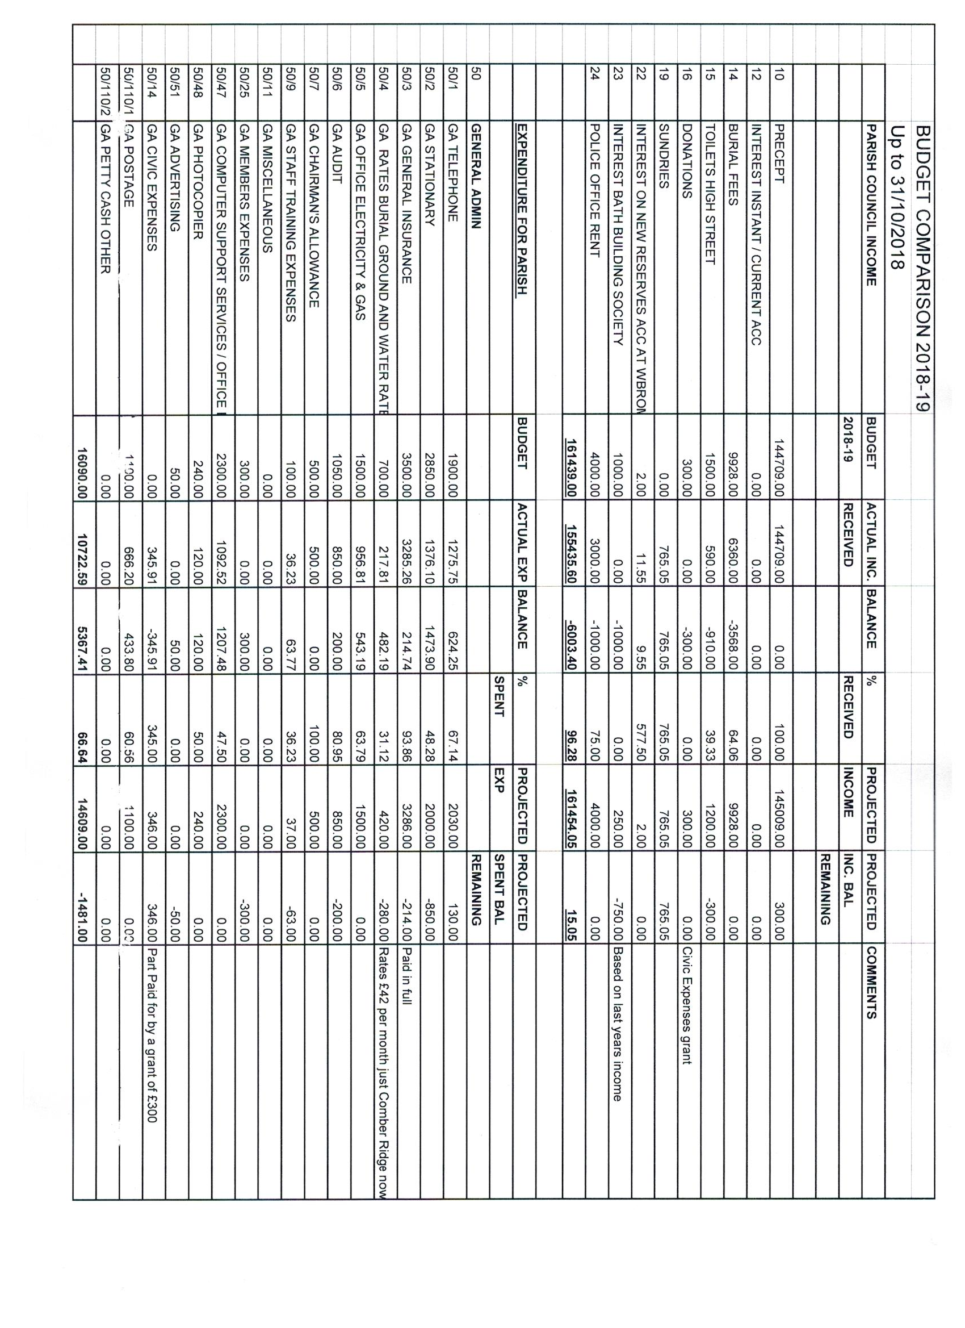
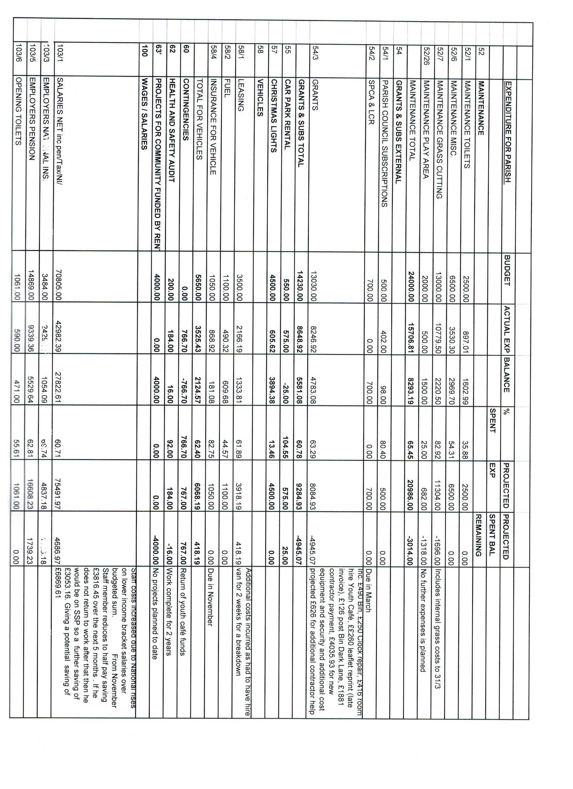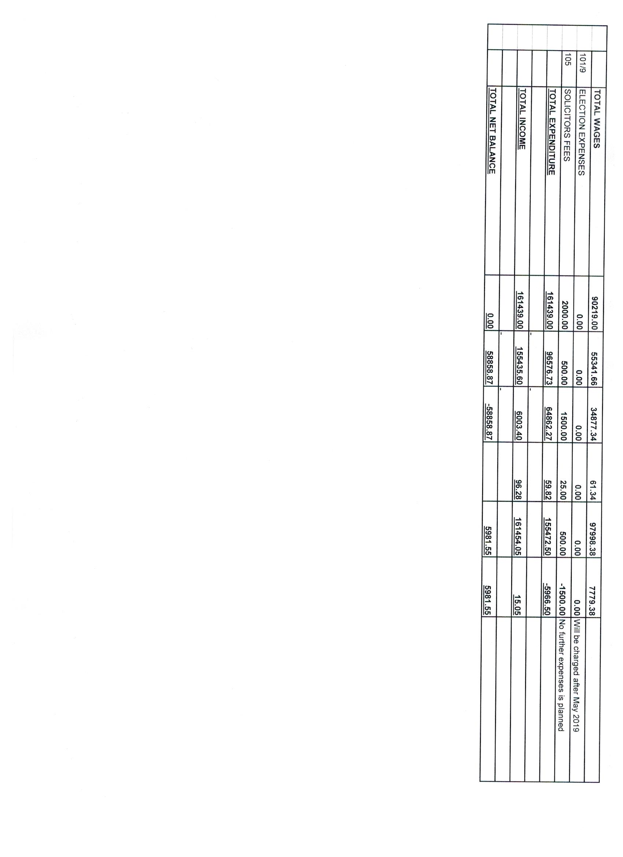

 | Proposed draft budget 2019/2020 | Item 10
 | PARISH COUNCIL INCOME | BUDGET | PROPOSED | COMMENTS
 |  | 2018-19 | BUDGET
 |  |  | 2019-20
 |  |  | 0% INC ON PRECEPT
10 | PRECEPT | 144709.00 | 144709.00
12 | INTEREST INSTANT / CURRENT ACC | 0.00 | 0.00
14 | BURIAL FEES | 9928.00 | 10225.00 | Increased by 3%
15 | TOILETS HIGH STREET | 1500.00 | 1200.00
16 | DONATIONS | 300.00 | 300.00
19 | SUNDRIES | 0.00 | 0.00
22 | INTEREST ON NEW RESERVES ACC AT WBROM | 2.00 | 10.00
23 | INTEREST BATH BUILDING SOCIETY | 1000.00 | 250.00 | Based on last years income
24 | POLICE OFFICE RENT | 4000.00 | 4000.00
 |  | 161439.00 | 160694.00
 | EXPENDITURE FOR PARISH | BUDGET | PROPOSED
 |  | 2018-19 | BUDGET
50 | GENERAL ADMIN
50/1 | GA TELEPHONE | 1900.00 | 2100.00
50/2 | GA STATIONARY | 2850.00 | 2850.00
50/3 | GA GENERAL INSURANCE | 3500.00 | 3500.00
50/4 | GA RATES BURIAL GROUND AND WATER RATES | 700.00 | 500.00 | Rates £42 per month just Comber Ridge now
50/5 | GA OFFICE ELECTRICITY & GAS | 1500.00 | 1500.00
50/6 | GA AUDIT | 1050.00 | 850.00
50/7 | GA CHAIRMAN'S ALLOWANCE | 500.00 | 500.00
50/9 | GA STAFF TRAINING EXPENSES | 100.00 | 100.00
50/11 | GA MISCELLANEOUS | 0.00 | 0.00
50/25 | GA MEMBERS EXPENSES | 300.00 | 200.00
50/47 | GA COMPUTER SUPPORT SERVICES / OFFICE EQUIP (2010) | 2300.00 | 2300.00
50/48 | GA PHOTOCOPIER | 240.00 | 240.00
50/51 | GA ADVERTISING | 50.00 | 0.00
50/14 | GA CIVIC EXPENSES | 0.00 | 0.00
50/110/1 | GA POSTAGE | 1100.00 | 1100.00
50/110/2 | GA PETTY CASH OTHER | 0.00 | 0.00
 |  | 16090.00 | 15740.00
 | EXPENDITURE FOR PARISH | BUDGET | PROPOSED
 |  |  | BUDGET
52 | MAINTENANCE
52/1 | MAINTENANCE TOILETS | 2500.00 | 2500.00
52/6 | MAINTENANCE MISC. | 6500.00 | 6500.00
52/7 | MAINTENANCE GRASS CUTTING | 13000.00 | 4240.00 | £1500 additional cost to cut KSCA field IS INCLUDED IN THIS FIGURE This is for the cutting of pitches March, Appril, October and 1/2 November. Envile Cricket Club will cut the main season.
52/26 | MAINTENANCE PLAY AREA | 2000.00 | 2000.00
 | MAINTENANCE TOTAL | 24000.00 | 15240.00
54 | GRANTS & SUBS EXTERNAL
54/1 | PARISH COUNCIL SUBSCRIPTIONS | 500.00 | 500.00
54/2 | SPCA & LCR | 700.00 | 700.00
54/3 | GRANTS | 13030.00 | 8389.00
 | GRANTS & SUBS TOTAL | 14230.00 | 9589.00
55 | CAR PARK RENTAL | 550.00 | 575.00
57 | CHRISTMAS LIGHTS | 4500.00 | 4500.00
58 | VEHICLES
58/1 | LEASING | 3500.00 | 3500.00
58/2 | FUEL | 1100.00 | 1400.00 | Increased due to using more fuel for mowers
58/4 | INSURANCE FOR VEHICLE | 1050.00 | 1050.00
 | TOTAL FOR VEHICLES | 5650.00 | 5950.00
60 | CONTINGENCIES | 0.00 | 0.00
62 | HEALTH AND SAFETY AUDIT | 200.00 | 0.00
63' | PROJECTS FOR COMMUNITY FUNDED BY RENT | 4000.00 | 4000.00
100 | WAGES / SALARIES
103/1 | SALARIES NET inc pen/Tax/NI/ | 70805.00 | 79000.00 | Includes small salary increase for inflation and based on this years ACTUAL costs
103/3 | EMPLOYERS NATIONAL INS. | 3484.00 | 6000.00
103/5 | EMPLOYERS PENSION | 14869.00 | 17000.00
103/6 | OPENING TOILETS | 1061.00 | 1100.00
 | TOTAL WAGES | 90219.00 | 103100.00
101/9 | ELECTION EXPENSES | 0.00 | 1000.00 | Will be charged after May 2019 £8445.47 is in reserves for this bill Balance to be taken from the Contingency fund
Appendix 2 to the minutes of the Finance Committee meeting held on the 21st November 2018
 | Proposed draft budget 2019/2020 | Item 10
 | PARISH COUNCIL INCOME | BUDGET | PROPOSED | COMMENTS
 |  | 2018-19 | BUDGET
 |  |  | 2019-20
 |  |  | 0% INC ON PRECEPT
10 | PRECEPT | 144709.00 | 144709.00
12 | INTEREST INSTANT / CURRENT ACC | 0.00 | 0.00
14 | BURIAL FEES | 9928.00 | 10225.00 | Increased by 3%
15 | TOILETS HIGH STREET | 1500.00 | 1200.00
16 | DONATIONS | 300.00 | 300.00
19 | SUNDRIES | 0.00 | 0.00
22 | INTEREST ON NEW RESERVES ACC AT WBROM | 2.00 | 10.00
23 | INTEREST BATH BUILDING SOCIETY | 1000.00 | 250.00 | Based on last year’s income
24 | POLICE OFFICE RENT | 4000.00 | 4000.00
 |  | 161439.00 | 160694.00
 | EXPENDITURE FOR PARISH | BUDGET | PROPOSED
 |  | 2018-19 | BUDGET
50 | GENERAL ADMIN
50/1 | GA TELEPHONE | 1900.00 | 2100.00
50/2 | GA STATIONARY | 2850.00 | 2850.00
50/3 | GA GENERAL INSURANCE | 3500.00 | 3500.00
50/4 | GA RATES BURIAL GROUND AND WATER RATES | 700.00 | 500.00 | Rates £42 per month just Comber Ridge now
50/5 | GA OFFICE ELECTRICITY & GAS | 1500.00 | 1500.00
50/6 | GA AUDIT | 1050.00 | 850.00
50/7 | GA CHAIRMAN'S ALLOWANCE | 500.00 | 500.00
50/9 | GA STAFF TRAINING EXPENSES | 100.00 | 100.00
50/11 | GA MISCELLANEOUS | 0.00 | 0.00
50/25 | GA MEMBERS EXPENSES | 300.00 | 200.00
50/47 | GA COMPUTER SUPPORT SERVICES / OFFICE EQUIP (2010) | 2300.00 | 2300.00
50/48 | GA PHOTOCOPIER | 240.00 | 240.00
50/51 | GA ADVERTISING | 50.00 | 0.00
50/14 | GA CIVIC EXPENSES | 0.00 | 0.00
50/110/1 | GA POSTAGE | 1100.00 | 1100.00
50/110/2 | GA PETTY CASH OTHER | 0.00 | 0.00
 |  | 16090.00 | 15740.00
 | EXPENDITURE FOR PARISH | BUDGET | PROPOSED
 |  |  | BUDGET
52 | MAINTENANCE
52/1 | MAINTENANCE TOILETS | 2500.00 | 2500.00
52/6 | MAINTENANCE MISC. | 6500.00 | 6500.00
52/7 | MAINTENANCE GRASS CUTTING | 13000.00 | 4240.00 | £1500 additional cost to cut KSCA field IS INCLUDED IN THIS FIGURE This is for the cutting of pitches March, April, October and 1/2 November. Enville Cricket Club will cut the main season.
52/26 | MAINTENANCE PLAY AREA | 2000.00 | 2000.00
 | MAINTENANCE TOTAL | 24000.00 | 15240.00
54 | GRANTS & SUBS EXTERNAL
54/1 | PARISH COUNCIL SUBSCRIPTIONS | 500.00 | 500.00
54/2 | SPCA & LCR | 700.00 | 700.00
54/3 | GRANTS | 13030.00 | 8389.00
 | GRANTS & SUBS TOTAL | 14230.00 | 9589.00
55 | CAR PARK RENTAL | 550.00 | 575.00
57 | CHRISTMAS LIGHTS | 4500.00 | 4500.00
58 | VEHICLES
58/1 | LEASING | 3500.00 | 3500.00
58/2 | FUEL | 1100.00 | 1400.00 | Increased due to using more fuel for mowers
58/4 | INSURANCE FOR VEHICLE | 1050.00 | 1050.00
 | TOTAL FOR VEHICLES | 5650.00 | 5950.00
60 | CONTINGENCIES | 0.00 | 0.00
62 | HEALTH AND SAFETY AUDIT | 200.00 | 0.00
63' | PROJECTS FOR COMMUNITY FUNDED BY RENT | 4000.00 | 4000.00
100 | WAGES / SALARIES
103/1 | SALARIES NET inc pen/Tax/NI/ | 70805.00 | 79000.00 | Includes small salary increase for inflation and based on this year’s ACTUAL costs
103/3 | EMPLOYERS NATIONAL INS. | 3484.00 | 6000.00
103/5 | EMPLOYERS PENSION | 14869.00 | 17000.00
103/6 | OPENING TOILETS | 1061.00 | 1100.00
 | TOTAL WAGES | 90219.00 | 103100.00
101/9 | ELECTION EXPENSES | 0.00 | 1000.00 | Will be charged after May 2019 £8445.47 is in reserves for this bill Balance to be taken from the Contingency fund
105 | SOLICITORS FEES | 2000.00 | 1000.00
 | TOTAL EXPENDITURE | 161439.00 | 160694.00
 | TOTAL INCOME | 161439.00 | 160694.00
 | TOTAL NET BALANCE | 0.00 | 0.00

Appendix 3 to the minutes of the Finance Committee meeting held on the 21st November 2018
COMBER RIDGE BURIAL GROUND FEE STRUCTURE TO APPLY FROM 1st APRIL 2019

 | 1st April 2018 (10% increase on 2017) | 1st April 2019 (3% increase on 2018)
First Interments, Coffin Burials | £865 | £890
First Interments, Ashes | £520 | £535
Subsequent Interments, Coffin Burials to include permit cost for removal/amendment to Headstones | £400 | £410
Subsequent Interments of Ashes to include permit cost for removal/amendment to Tablets | £310 | £320
Interment of Infants and Young Children up to age 12 years | £190 | £195
Scattering of Cremated Remains | £107 | £110
Amendments permit of Headstones/Tablets i.e. cleaning, reguild etc. | £75 | £77

* This fee to be applied only to infants above six weeks of age and to young children up to (and including) 12 years of age interred in single graves within this designated area.

Those infants from 6 weeks of age and children interred in other grave spaces to attract the level of fee appropriate to the grave space occupied

Item 7 Headstone testing

.

