MINUTES OF A MEETING OF THE FINANCE AND GENERAL PURPOSES COMMITTEE
OF KINVER PARISH COUNCIL HELD AT 95 HIGH STREET, KINVER ON WEDNESDAY 17th APRIL 2019
_______________________________________________________

Councillors: D Light (Chairman), H Williams (ex-officio), Miss V Webb, JK Hall, Mrs C Allen,

- APOLOGIES FOR ABSENCE

Councillors P Wooddisse (Vice Chairman), BR Edwards and I G Sadler sent their apologies for the meeting.

- DECLARATIONS OF PECUNIARY INTERESTS

None were declared.

- MINUTES OF THE MEETING OF 17TH FEBRUARY 2019

The minutes of the meeting held on 17th February were approved and signed as a true record of that meeting.

- MATTERS ARISING FROM PREVIOUS MINUTES

It was noted that the clock has now been hung in the library, and an official opening ceremony is to be arranged.

- BUDGET COMPARISON AND TO RECEIVE THE ACCOUNTS FROM 1ST APRIL TO 31ST MARCH 2019 AS PREPARED BY THE RFO

The accounts as attached as Appendix 1 to these minutes: the figures were reviewed and noted.

It was Resolved to Recommend to the Parish Council that the Year-end accounts as set as Appendix 1 to these minutes be accepted. On a vote this was unanimous.

- TO RECEIVE THE INTERNAL AUDITORS REPORT FOR 2017 / 2018

The internal Auditors report as set out as appendix 2 to these minutes was accepted. It was Resolved to Recommend to the Parish Council that the Year-end accounts as set as Appendix 2 to these minutes be accepted. On a vote this was unanimous.

- BALANCES REMAINING AS AT 31st MARCH 2018

Balances remaining as at the 31st March 2019 are detailed below, along with the explanation of balances held in all of the bank accounts:-

The budget summary is below:-

TOTAL EXPENDITURE | 161439.00 | 163955.90 | -2516.90
TOTAL INCOME | 161439.00 | 164354.70 | -2915.70
TOTAL NET BALANCE | 0.00 | 398.80 | -398.80

The bank balances after all of the invoices relating to the financial year 2018/19 are below:-

BARCLAYS BANK £1,687.67*
.COOPERATIVE BANK C & I £26.38
Bath Building Society £37,201.78
Reserves West Bromwich £30,441.72
Total £69,357.55

*In summary this is the VAT reclaim figure for the last quarter and the balance remaining from this year’s budget

Break down of balances held:-

Barclays and Co-operative bank account are current accounts

West Bromwich Account:-

Play Area | 5000.00
Contingency | 3500.00
Election Expenses | 8445.47
Xmas Lights | 5362.83
Balance from year end 31/3/18 | 8133.42
 | 30441.72
Bath Building Society:-

£30,000.00 reserves
£7201.78 for future Council Projects

This was noted.

- TO DISCUSS MOVING SID AS REFERRED FROM THE APRIL PARISH COUNCIL MEETING

Previous minutes on this matter:-

65/19. To discuss the purchase / location of a further SID

Minute from the Finance Committee held on the 20th February:-

The following recommendation was received from the Leisure and Amenities Committee to purchase a new SID, socket and pole at a cost of £2000. The Committee agreed that funding is available from the Community budget line 104, but some members of the Committee had reservations if this was actually best value for money, and requested that this is a full agenda item for the next Council meeting, so the proposal can be fully discussed.

Members agreed unanimously that the Clerk should:

- purchase 5 more removable sockets at a cost of circa £500.00.
- Get a quotation form the Company that supplied the SID signs for moving them from one location to another.
It was agreed to defer the purchase of an additional SID and post to the next meeting for members to decide whether a third camera should be purchased.

The sockets have been ordered. The cost for the company to come in move the signs approx. 4 times per year, at a cost of £135 per unit per visit. It was agreed to refer this to Finance for funding, if funding can be found then delegated authority was given to the Committee to engage Morelock Signs to move the cameras initially until the staffing issues are resolved.

Members agreed to leave their current locations until there is sufficient staff to deal with moving the signs. It was noted that the sockets had been ordered and a site at Stourton identified with the landowners permission, the Clerk is organising for the company that has supplied the signs, to double check that this location is suitable and the sign will work correctly in the proposed location.

- TO DISCUSS CHANGING BANK ACCOUNT

The Clerk has contacted Handel’s bank in Stourbridge via email and called them for further details on opening an account but has not received any response. Cllr Mrs C Allen agreed to pop into the bank and speak with them when she is in Stourbridge.

Members agreed to defer this item until the next meeting.

10. TO DISCUSS FINANCIAL IMPLICATIONS ON STAFFING ISSUES

The Clerk reported to the meeting the final costs on this matter, these were noted.

11 DATE OF NEXT MEETING

Date of the next meeting is Wednesday 22nd May 2019.

- ITEMS FOR FUTURE MEETINGS

Last date for items to be put on the agenda for the next meeting is 15th May 2019

National Trust Grant £500
Toilet costs for Kinver Edge toilets
Insurance quotations

- RECOMMENDATIONS TO THE PARISH COUNCIL

It was Resolved to Recommend to the Parish Council that:-

- the year-end accounts as set as Appendix 1 and the Internal Auditors report as set out as Appendix 2 to these minutes be accepted.

Appendix 1 to the minutes of the Finance Committee held on the 17TH April 2019
Item 5
KINVER PARISH COUNCIL
Monthly Balance Sheet as at: 31/03/2019
Barclays Bank
Unpresented Cheques |  |  | Unpresented Receipts
 | 206.76
TOTAL | 206.76 |  |  | 0.00
Computer Figures Barclays Bank acc. |  | 4061.36
less unpresented |  | 206.76
Total |  | 4268.12
Bank Statement Figure |  | 4268.12
Other bank account balances
Bath Building Society |  | 37201.78
West Bromwich Building Society |  | 30441.72
Co-Operative Bank |  | 26.38
 |  | 71938.00

Financial Budget Comparison
Comparison between 01/04/18 and 31/03/19 inclusive. Includes due and unpaid transactions.
Excludes transactions with an invoice date prior to 01/04/18
2018/2019 Actual Net Balance
INCOME
Council
13 INTEREST BATH BUILDING £1,000.00 £350.09 -£649.91
SOCIETY
14 BURIAL FEES £9,928.00 £12,650.00 £2,722.00
15 TOILET INCOME £1,500.00 £850.00 -£650.00
16 DONATIONS £300.00 £0.00 -£300.00
17 PRECEPT £144,709.00 £144,709.00 £0.00
19 SUNDRIES £0.00 £784.06 £784.06
20 TOILET GRANT SSDC £0.00 £0.00 £0.00
22 INTEREST WEST BROM £2.00 £11.55 £9.55
ACCOUNT - CHARITY ACC
24 SANTANDER BOND £0.00 £0.00 £0.00
26 RENT FROM DOWN STAIRS £4,000.00 £5,000.00 £1,000.00
OFFICE
Total Council £161,439.00 £164,354.70 £2,915.70
Total Income £161,439.00 £164,354.70 £2,915.70
EXPENDITURE
Council
51 GENERAL ADMINISTRATION
51/1 TELEPHONE £1,900.00 £1,698.31 £201.69
51/2 STATIONARY £2,850.00 £2,728.30 £121.70
51/3 GENERAL INSURANCE £3,500.00 £3,285.26 £214.74
51/4 RATES £700.00 £619.54 £80.46
51/5 OFFICE ELECTRICITY AND GAS £1,500.00 £1,970.06 -£470.06
51/6 AUDIT £1,050.00 £850.00 £200.00
51/7 CHAIRMAN’S ALLOWANCE £500.00 £500.00 £0.00
51/8 STAFF TRAINING EXPENSES £100.00 £0.00 £100.00
51/9 MISCELLANEOUS £0.00 £36.23 -£36.23
51/10 MEMBERS EXPENSES £300.00 £184.05 £115.95
51/11 COMPUTER SUPPORT £2,300.00 £1,970.36 £329.64
SERVICES
51/12 PHOTOCOPIER £240.00 £240.00 £0.00
51/13 ADVERTISING £50.00 £0.00 £50.00
51/14 CIVIC EXPENSES £0.00 £345.91 -£345.91
51/15 POSTAGE £1,100.00 £1,115.70 -£15.70
51/16 MISC PETTY CASH £0.00 £0.00 £0.00
51 Total £16,090.00 £15,543.72 £546.28
53 MAINTENANCE
53/2 MAINTENANCE TOILETS £2,500.00 £2,344.11 £155.89
53/4 MAINTENANCE MISC £6,500.00 £5,106.04 £1,393.96
04/04/19 10:22 AM Vs: Kinver Parish Council Page 1 of 2
Financial Budget Comparison
Comparison between 01/04/18 and 31/03/19 inclusive. Includes due and unpaid transactions.
Excludes transactions with an invoice date prior to 01/04/18
2018/2019 Actual Net Balance
53/41 MAINTENANCE GRASS £13,000.00 £10,779.50 £2,220.50
CUTTING
53/42 MAINTENANCE PLAY AREA £2,000.00 £682.00 £1,318.00
53 Total £24,000.00 £18,911.65 £5,088.35
55 CAR PARK RENT £550.00 £575.00 -£25.00
57 CHRISTMAS ILLUMINATIONS £4,500.00 £3,128.69 £1,371.31
59 INTERNAL GRANTS NO £0.00 £0.00 £0.00
LONGER USED
60 CONTINGENCIES £0.00 £766.70 -£766.70
61 VEHICLES - BARCLAYS BANK
61/1 LEASING £3,500.00 £4,565.46 -£1,065.46
61/2 FUEL £1,100.00 £804.42 £295.58
61/4 INSURANCE FOR VEHICLE £1,050.00 £868.92 £181.08
61 Total £5,650.00 £6,238.80 -£588.80
62 HEALTH AND SAFETY £200.00 £345.00 -£145.00
63 GRANTS AND SUBS
EXTERNAL BARCLAYS
ACCOUNT
63/1 PARISH COUNCIL SUBS £500.00 £402.00 £98.00
63/2 SPCA AND LCR £700.00 £694.00 £6.00
63/3 GRANTS £13,030.00 £11,971.92 £1,058.08
63 Total £14,230.00 £13,067.92 £1,162.08
64 GARAGE PROJECT £0.00 £0.00 £0.00
101 ELECTION EXPENSES £0.00 £0.00 £0.00
103 WAGES / SALARIES
BARCLAYS BANK
103/1 SALARIES £70,805.00 £78,254.17 -£7,449.17
103/2 TAX AND NI FOR EMPLOYEES £0.00 £0.00 £0.00
103/3 EMPLOYERS NATIONAL £3,484.00 £5,622.50 -£2,138.50
INSURANCE
103/4 EMPLOYEES PENSION £0.00 £0.00 £0.00
103/5 EMPLOYERS PENSION £14,869.00 £18,911.75 -£4,042.75
103/6 OPENING PUBLIC TOILETS £1,061.00 £1,250.00 -£189.00
103 Total £90,219.00 £104,038.42 -£13,819.42
104 COMMUNITY PROJECTS £4,000.00 £0.00 £4,000.00
105 LEGAL FEES £2,000.00 £1,340.00 £660.00
Total Council £161,439.00 £163,955.90 -£2,516.90
Total Expenditure £161,439.00 £163,955.90 -£2,516.90
Total Income £161,439.00 £164,354.70 £2,915.70
Total Expenditure £161,439.00 £163,955.90 -£2,516.90
Total Net Balance £0.00 £398.80
04/04/19 10:23 AM Vs: Kinver Parish Council Page 2 of 2

Summary Trial Balance
Year ending 31/03/19
Credit Debit
Income
Income 5,000.00
Precept 144,709.00
Agency Services reimbursements 0.00
Loan/Capital Receipts 0.00
Interest on Investments 361.64
Sale of Assets 0.00
Burial fees 12,650.00
Rights of Way 0.00
Toilet Income 850.00
Rents received 0.00
Donations and Sundries 784.06
Expenditure
Expenditure 5,580.39
General Administration 21,857.87
Agency Services 0.00
S. 137 Payments 0.00
Capital Schemes 0.00
Provision for Doubtful Debts 0.00
Interest on Long Term Debts 0.00
General Administration - Petty cash/High St Toilet cleaning 0.00
Maintenance 0.00
Burial Ground 18,911.65
Grants and Subscriptions 13,067.92
Car park rentals 575.00
Millennium Fund 0.00
Loan repayment 0.00
Employment Advice Centre 0.00
Wages / Salaries 104,038.42
Church - Methodist rent 0.00

Expenditure
Balance Sheet Assets
VAT Recoverable 1,206.25
Debtors 2,000.00
Payment in Advance 0.00
Cash in Hand && at Bank 71,731.24
Investments 0.00
Loans Made 0.00
Balance Sheet Liabilities
Loans Received 0.00
VAT Payable 0.00
Creditors 5,573.78
Receipts in Advance 0.00
Reserves (at start of year) 69,040.26
Trial Balance Total 238,968.74 238,968.74
Total of credits and debits match.

Income and Expenditure Account Unaudited
31/03/18 31/03/19
£ £
INCOME
9,910.00 Burial fees 12,650.00
0.00 Exchequer Bond 0.00
0.00 Rights of Way 0.00
1,110.00 Toilet Income 850.00
0.00 Rents received 0.00
3,000.00 Income 5,000.00
3,576.50 Donations and Sundries 784.06
144,709.00 Precept 144,709.00
0.00 Agency Services reimbursements 0.00
0.00 Loan/Capital Receipts 0.00
275.28 Interest on Investments 361.64
0.00 Sale of Assets 0.00
162,580.78 TOTAL INCOME 164,354.70
EXPENDITURE
24,732.78 General Administration 21,857.87
0.00 Agency Services 0.00
0.00 S. 137 Payments 0.00
0.00 Capital Schemes 0.00
0.00 Provision for Doubtful Debts 0.00
0.00 Interest on Long Term Debts 0.00
0.00 General Administration - Petty cash/High St toilet cleaning 0.00
0.00 Maintenance 0.00
23,589.84 Burial Ground 18,911.65
5,485.17 Grants and Subscriptions 13,067.92
0.00 Car park rentals 575.00
0.00 Millennium Fund 0.00
0.00 Loan repayment 0.00
0.00 Employment Advice Centre 0.00
10,406.38 Expenditure 5,580.39
94,733.07 Wages / Salaries 104,038.42
0.00 Church - Methodist rent 0.00
158,947.24 TOTAL EXPENDITURE 164,031.25
65,406.72 Balance as at 01/04/18 69,040.26
162,580.78 Add Total Income 164,354.70
227,987.50 233,394.96
158,947.24 Deduct Total Expenditure 164,031.25
0.00 Stock Adjustment 0.00
0.00 Transfer to/ from reserves 0.00
69,040.26 Balance as at 31/03/19 69,363.71
Signed
Chair Clerk / Responsible Financial
05/04/19 08:13 AM Vs: 8.18.01 Kinver Parish Council Page 1 of 1

Consolidated Balance Sheet Unaudited
31/03/18 31/03/19
£ £
Long Term assets
0.00 Investments 0.00
0.00 Long Term Debts 0.00
0.00 TOTAL LONG TERM ASSETS 0.00
Current assets
0.00 Investments 0.00
0.00 Loans Made 0.00
0.00 Investments 0.00
0.00 Stocks 0.00
1,155.17 VAT Recoverable 1,206.25
0.00 Debtors 2,000.00
0.00 Payment in Advance 0.00
73,996.94 Cash in Hand & at Bank 71,731.24
75,152.11 TOTAL CURRENT ASSETS 74,937.49
75,152.11 TOTAL ASSETS 74,937.49
Current liabilities
0.00 Loans Received 0.00
0.00 Temporary Borrowing 0.00
0.00 VAT Payable 0.00
6,111.85 Creditors 5,573.78
0.00 Receipts in Advance 0.00
6,111.85 TOTAL CURRENT LIABILITIES 5,573.78
69,040.26 TOTAL ASSETS LESS CURRENT 69,363.71
0.00 Long Term Borrowing 0.00
0.00 Deferred Liabilities 0.00
0.00 Deferred Credits 0.00
0.00 0.00
69,040.26 NET ASSETS 69,363.71
Represented by
69,040.26 General Reserve 69,363.71
RESERVES
0.00 Asset Replacement Reserve 0.00
69,040.26 69,363.71
Signed
Chairman Responsible Financial Officer
Date
AUDIT OPINION
05/04/19 08:16 AM Vs: 8.18.01 Kinver Parish Council Page 1 of 1
Financial Summary - Cashbook
Summary between 01/04/18 and 31/03/19 inclusive. Includes due and unpaid transactions.
Balances at the start of the year
Ordinary Accounts
.BARCLAYS BANK £14,822.12
.COOPERATIVE BANK C & I £26.38
Bath Building Society £36,851.69
Reserves West Bromwich £22,296.75
Total £73,996.94
RECEIPTS Net Vat Gross
Council £171,776.69 £0.00 £171,776.69
Total Receipts £171,776.69 £0.00 £171,776.69
PAYMENTS Net Vat Gross
Council £170,143.10 £6,272.98 £176,416.08
Total Payments £170,143.10 £6,272.98 £176,416.08
Closing
Ordinary Accounts
.BARCLAYS BANK £1,687.67
.COOPERATIVE BANK C & I £26.38
Bath Building Society £37,201.78
Reserves West Bromwich £30,441.72
Total £69,357.55
Signed
Chair Clerk / Responsible Financial

05/04/19 08:24 AM Vs: Kinver Parish Council Page 1 of 1

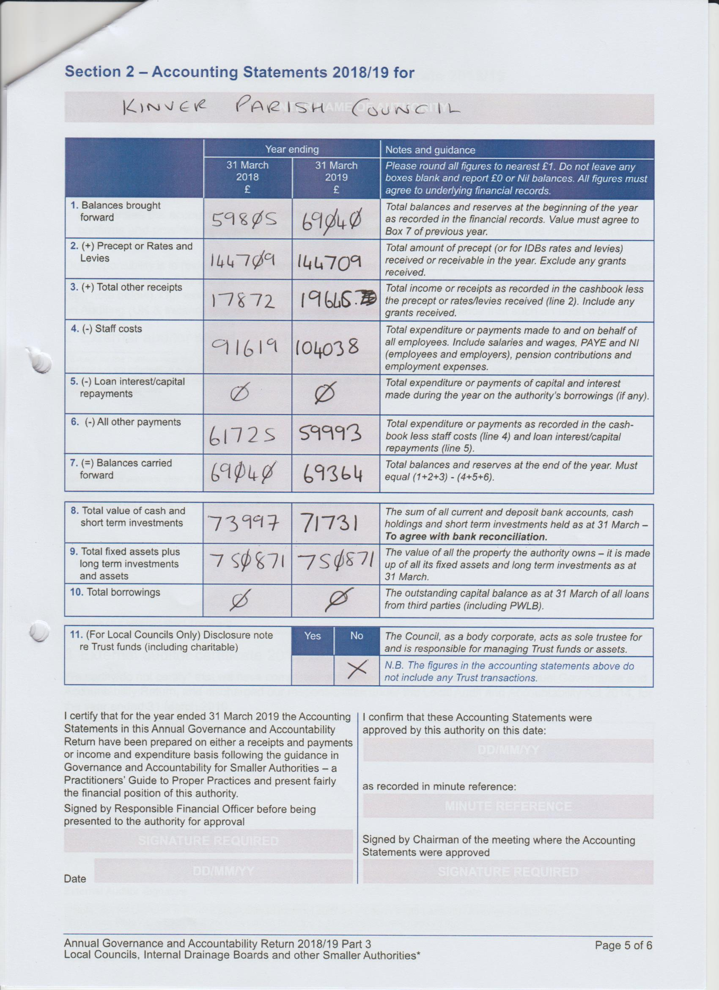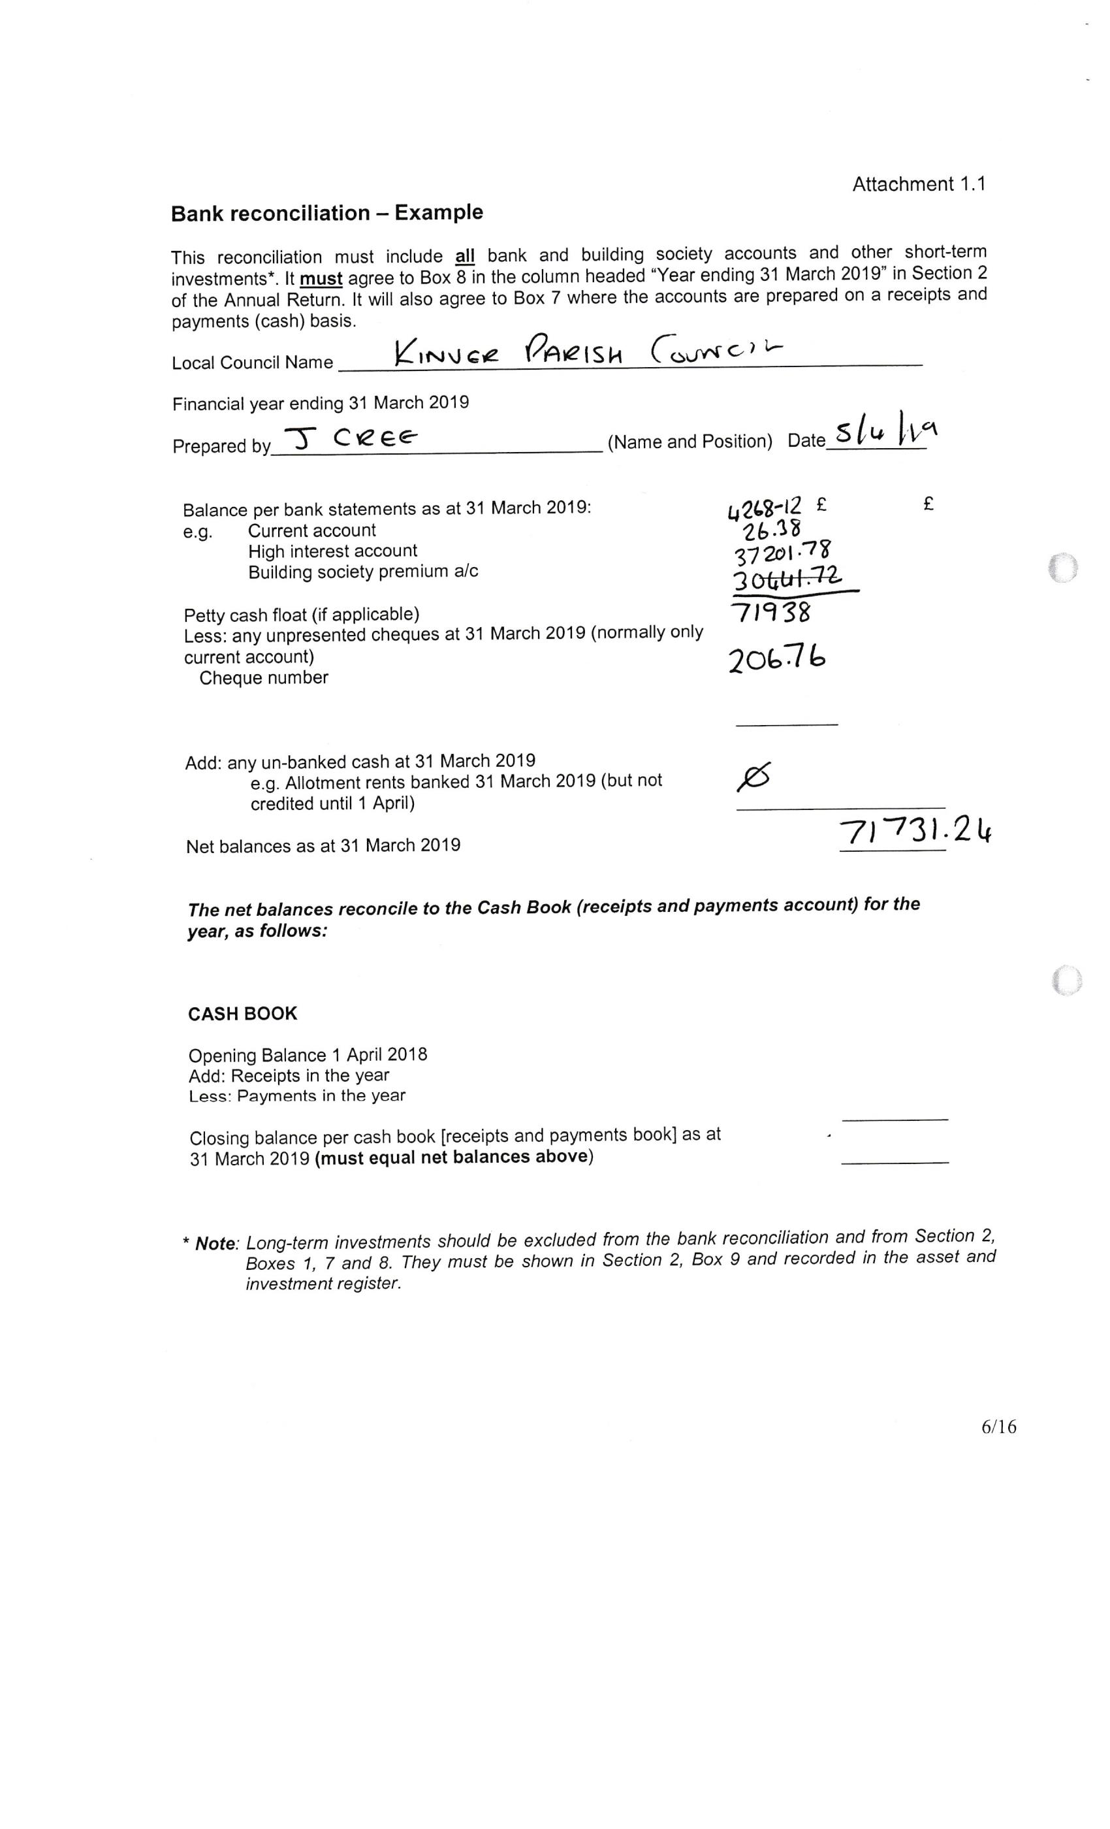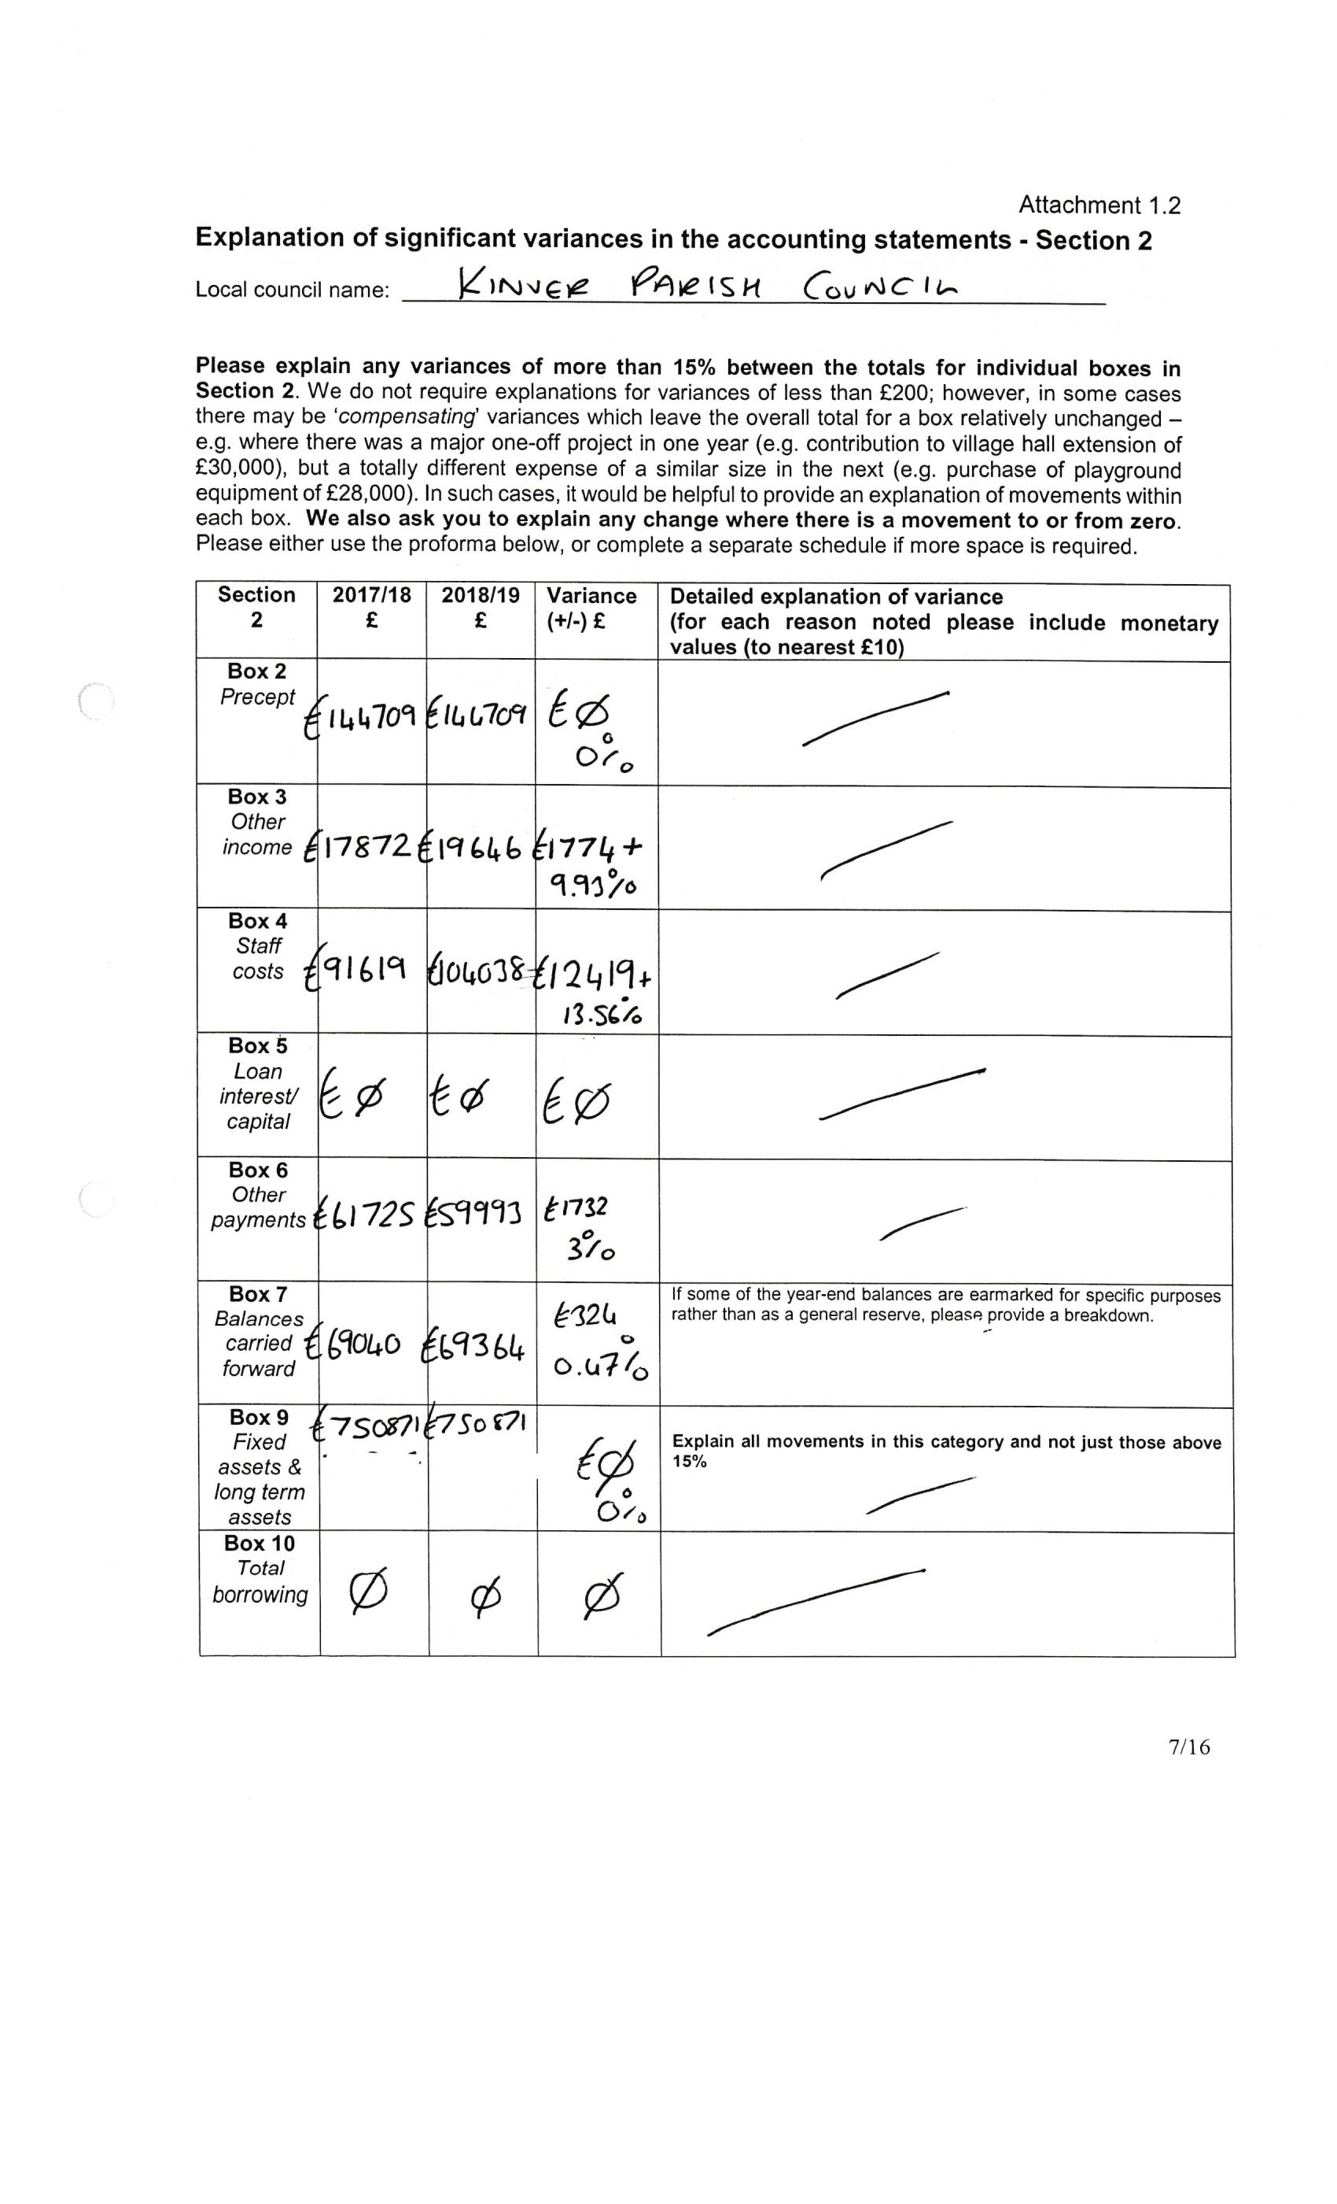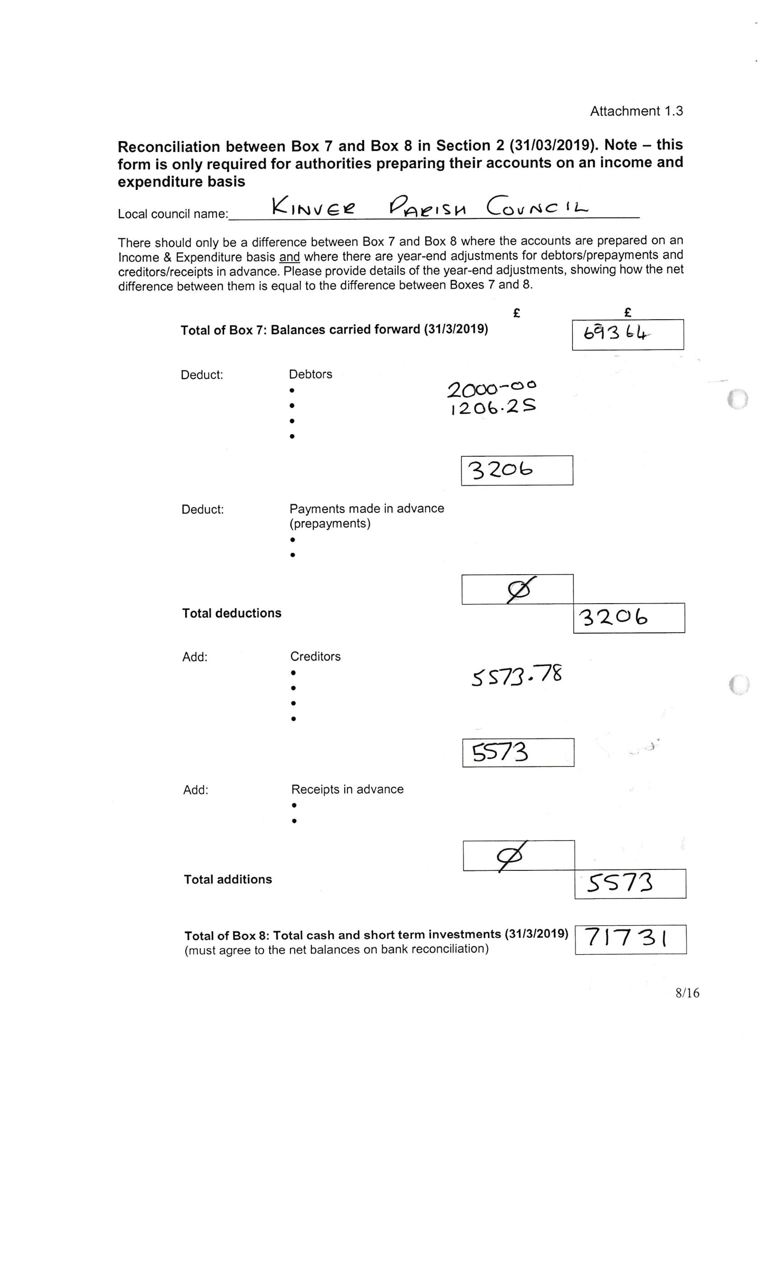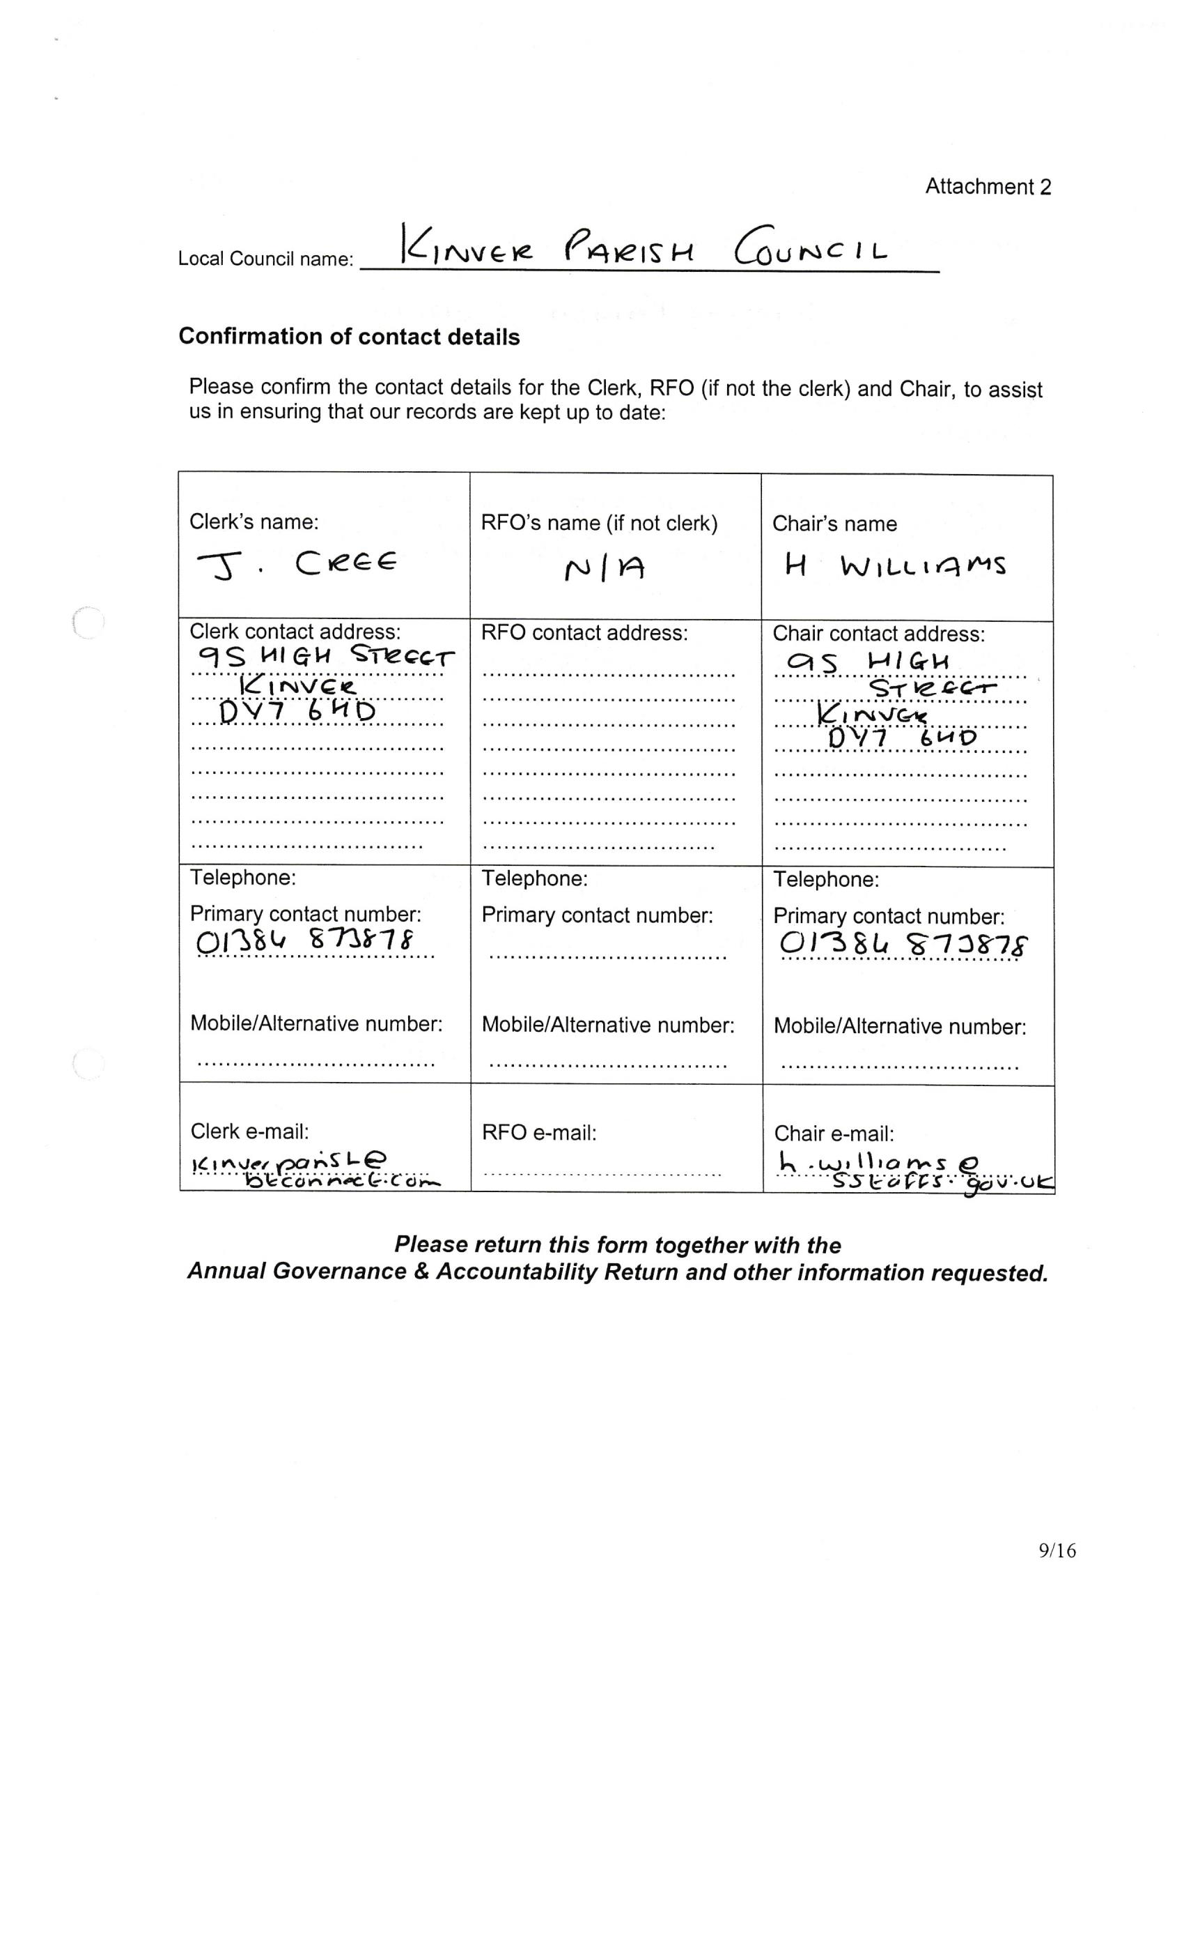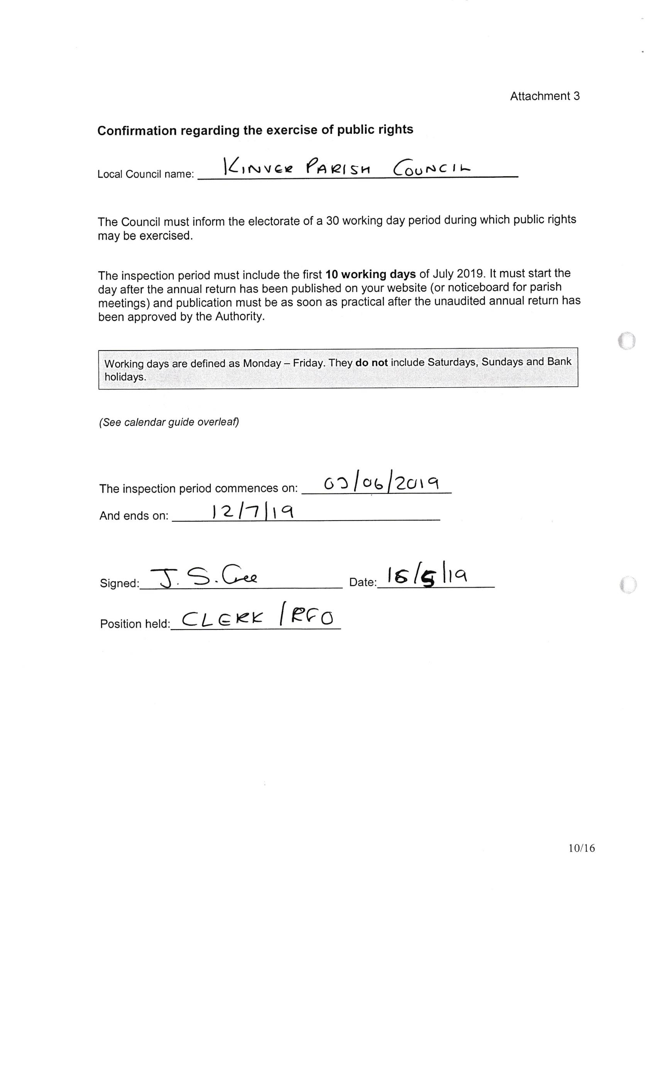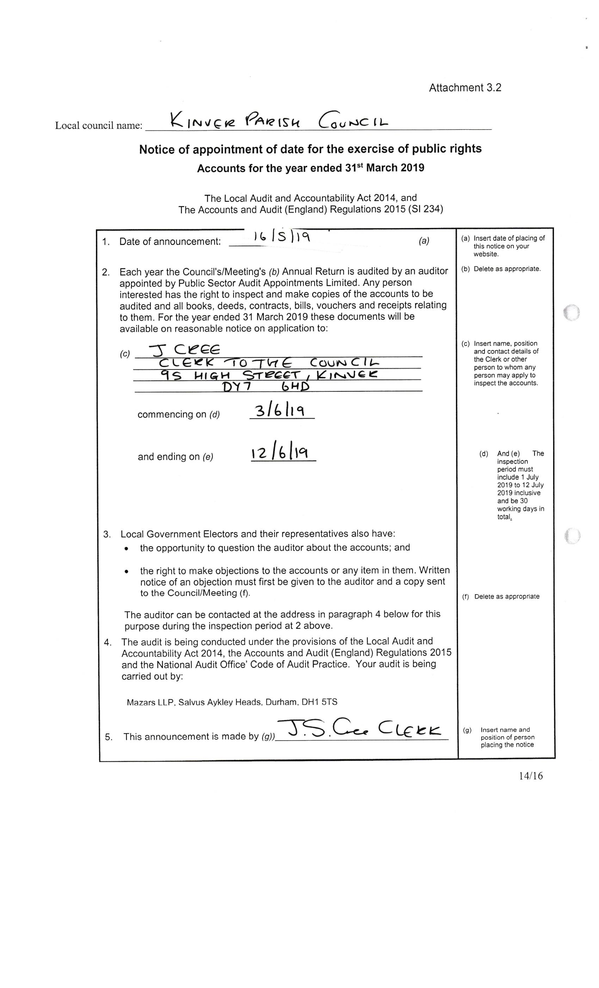
 | BUDGET COMPARISON 2018-19
 | Up to 31/03/2019
 | PARISH COUNCIL INCOME | BUDGET | ACTUAL INC. | BALANCE | %
 |  | 2018-19 | RECEIVED |  | RECEIVED
10 | PRECEPT | 144709.00 | 144709.00 | 0.00 | 100.00
12 | INTEREST INSTANT / CURRENT ACC | 0.00 | 0.00 | 0.00 | 0.00
14 | BURIAL FEES | 9928.00 | 12650.00 | 2722.00 | 127.42
15 | TOILETS HIGH STREET | 1500.00 | 850.00 | -650.00 | 56.67
16 | DONATIONS | 300.00 | 0.00 | -300.00 | 0.00
19 | SUNDRIES | 0.00 | 784.06 | 784.06 | 765.05
22 | INTEREST ON NEW RESERVES ACC AT WBROM | 2.00 | 11.55 | 9.55 | 577.50
23 | INTEREST BATH BUILDING SOCIETY | 1000.00 | 350.09 | -649.91 | 35.01
24 | POLICE OFFICE RENT | 4000.00 | 5000.00 | 1000.00 | 125.00
 |  | 161439.00 | 164354.70 | 2915.70 | 101.81
 | EXPENDITURE FOR PARISH | BUDGET | ACTUAL EXP | BALANCE | %
 |  |  |  |  | SPENT
50 | GENERAL ADMIN
50/1 | GA TELEPHONE | 1900.00 | 1698.31 | 201.69 | 89.38
50/2 | GA STATIONARY | 2850.00 | 2728.30 | 121.70 | 95.73
50/3 | GA GENERAL INSURANCE | 3500.00 | 3285.26 | 214.74 | 93.86
50/4 | GA RATES BURIAL GROUND AND WATER RATES | 700.00 | 619.54 | 80.46 | 88.51
50/5 | GA OFFICE ELECTRICITY & GAS | 1500.00 | 1970.06 | -470.06 | 131.34
50/6 | GA AUDIT | 1050.00 | 850.00 | 200.00 | 80.95
50/7 | GA CHAIRMAN'S ALLOWANCE | 500.00 | 500.00 | 0.00 | 100.00
50/9 | GA STAFF TRAINING EXPENSES | 100.00 | 0.00 | 100.00 | 0.00
50/11 | GA MISCELLANEOUS | 0.00 | 36.23 | -36.23 | 0.00
50/25 | GA MEMBERS EXPENSES | 300.00 | 184.05 | 115.95 | 61.35
50/47 | GA COMPUTER SUPPORT SERVICES / OFFICE EQUIP (2010) | 2300.00 | 1970.36 | 329.64 | 85.67
50/48 | GA PHOTOCOPIER | 240.00 | 240.00 | 0.00 | 100.00
50/51 | GA ADVERTISING | 50.00 | 0.00 | 50.00 | 0.00
50/14 | GA CIVIC EXPENSES | 0.00 | 345.91 | -345.91 | 345.00
50/110/1 | GA POSTAGE | 1100.00 | 1115.70 | -15.70 | 101.43
50/110/2 | GA PETTY CASH OTHER | 0.00 | 0.00 | 0.00 | 0.00
 |  | 16090.00 | 15543.72 | 546.28 | 96.60
 | EXPENDITURE FOR PARISH | BUDGET | ACTUAL EXP | BALANCE | %
 |  |  |  |  | SPENT
52 | MAINTENANCE
52/1 | MAINTENANCE TOILETS | 2500.00 | 2344.11 | 155.89 | 93.76
52/6 | MAINTENANCE MISC. | 6500.00 | 5106.04 | 1393.96 | 78.55
52/7 | MAINTENANCE GRASS CUTTING | 13000.00 | 10779.50 | 2220.50 | 82.92
52/26 | MAINTENANCE PLAY AREA | 2000.00 | 682.00 | 1318.00 | 34.10
 | MAINTENANCE TOTAL | 24000.00 | 18911.65 | 5088.35 | 78.80
54 | GRANTS & SUBS EXTERNAL
54/1 | PARISH COUNCIL SUBSCRIPTIONS | 500.00 | 402.00 | 98.00 | 80.40
54/2 | SPCA & LCR | 700.00 | 694.00 | 6.00 | 99.14
54/3 | GRANTS | 13030.00 | 11971.92 | 1058.08 | 91.88
 | GRANTS & SUBS TOTAL | 14230.00 | 13067.92 | 1162.08 | 91.83
55 | CAR PARK RENTAL | 550.00 | 575.00 | -25.00 | 104.55
57 | CHRISTMAS LIGHTS | 4500.00 | 3128.69 | 1371.31 | 69.53
58 | VEHICLES
58/1 | LEASING | 3500.00 | 4565.46 | -1065.46 | 130.44
58/2 | FUEL | 1100.00 | 804.42 | 295.58 | 73.13
58/4 | INSURANCE FOR VEHICLE | 1050.00 | 868.92 | 181.08 | 82.75
 | TOTAL FOR VEHICLES | 5650.00 | 6238.80 | -588.80 | 110.42
60 | CONTINGENCIES | 0.00 | 766.70 | -766.70 | 766.70
62 | HEALTH AND SAFETY AUDIT | 200.00 | 345.00 | -145.00 | 172.50
63' | PROJECTS FOR COMMUNITY FUNDED BY RENT | 4000.00 | 0.00 | 4000.00 | 0.00
100 | WAGES / SALARIES
103/1 | SALARIES NET inc pen/Tax/NI/ | 70805.00 | 78254.17 | -7449.17 | 110.52
103/3 | EMPLOYERS NATIONAL INS. | 3484.00 | 5622.50 | -2138.50 | 161.38
103/5 | EMPLOYERS PENSION | 14869.00 | 18911.75 | -4042.75 | 127.19
103/6 | OPENING TOILETS | 1061.00 | 1250.00 | -189.00 | 117.81
 | TOTAL WAGES | 90219.00 | 104038.42 | -13819.42 | 115.32
101/9 | ELECTION EXPENSES | 0.00 | 0.00 | 0.00 | 0.00
105 | SOLICITORS FEES | 2000.00 | 1340.00 | 660.00 | 67.00
 | TOTAL EXPENDITURE | 161439.00 | 163955.90 | -2516.90 | 101.56
 | TOTAL INCOME | 161439.00 | 164354.70 | -2915.70 | 101.81
 | TOTAL NET BALANCE | 0.00 | 398.80 | -398.80

Fixed assets as at 31st March 2019
 | 2019
CONTENTS 95 HIGH STREET | £12,629
CLOCK SHELTER | £43,709
DOG BINS / 14 BINS | £2,270
BENCHES / SEATS | £12,145
BUS SHELTERS | £5,549
NOTICE BOARDS | £2,913
WAR MEMORIAL | £42,293
MAINTENANCE MACHINERY | £3,920
CHAIRMAN'S BADGE AND CHAIN | £3,376
S HARRIS CUP AND BOARD | £1,575
VILLAGE SIGNS | £4,527
CHRISTMAS LIGHTS | £7,792
GATES AND FENCES | £11,368
PLAY EQUIPMENT | £194,496
95 HIGH STREET | £217,764
TOILET BLOCK HIGH STREET | £108,879
TOILET BLOCK KINVER EDGE | £48,895
GARAGE AND STORE COMBER RIDGE | £16,665
STONE TROUGHS | £1,619
SPEED SIGNS | £6,036
CCTV CAMERA KSCA CAR PARK | £2,450
 | £750,870.77

Appendix 2 to the minutes of the Finance Committee held on the 17TH April 2019
