MINUTES OF A MEETING OF THE FINANCE AND GENERAL PURPOSES COMMITTEE
OF KINVER PARISH COUNCIL HELD VIA ZOOM SOFTWARE AND VIA ZOOM AT 95 HIGH STREET, KINVER ON WEDNESDAY 18th NOVEMBER 2020
_______________________________________________________

Councillors: D Light (Chairman), JK Hall (ex-officio), I G Sadler, BR Edwards (Vice Chairman), Mrs C Allen, S Anderson, P Wooddisse, Miss V Webb and G Sisley attended via zoom.

- APOLOGIES FOR ABSENCE

Councillor H Williams was not in attendance.

- DECLARATIONS OF PECUNIARY INTERESTS

None were declared.

- MINUTES OF THE MEETING OF 16TH SEPTEMBER 2020

The minutes of the meeting held on 16th September 2020 were approved and signed as a true record of that meeting.

- BUDGET COMPARISON AND TO RECEIVE THE ACCOUNTS TO SEPTEMBER 2020 AS PREPARED BY THE RFO

The accounts as attached as Appendix 1 to these minutes: the figures were reviewed and noted.

It was Resolved to Recommend to the Parish Council that the accounts as set as Appendix 1 to these minutes be accepted. On a vote this was unanimous.

- FUNDING REQUESTS AND ITEMS REFERRED FROM THE PARISH COUNCIL

The members of the Committee agreed to Recommend to the Parish Council to purchase the 5 x A3 plastic signs at a total cost of £72.70. On a vote this was agreed.

Members discussed and agreed to propose to the Parish Council the recommendation from the Leisure and Amenities Committee that the cost of £137.88 (inc VAT) is given permission to allow a quote to be prepared for the re-instatement of the water supply at the Giants Well, as a last resort if discussions with South Staffs Water and Severn Trent to get this funded via a Community fund is not successful. On a vote this was carried.

- BUDGET SETTING AND ASSOCIATED PRECEPT FOR 2021-22

It was proposed by Councillor S Anderson and seconded by Councillor JK Hall to Recommend to the Parish Council that the budget set out as appendix 2 to these minutes be accepted and a precept to be set at £134709.00. On a vote this was unanimous.

- TO DISCUSS AND RECOMMEND TO THE PARISH COUNCIL A FORMAL RESERVES POLICY FOR THE PARISH COUNCIL

It was Resolved to Recommend to the Parish Council that the Reserves Policy as set out as appendix 3 to these minutes be accepted. On a vote this was unanimous.

- TO RECEIVE THE EXTERNAL AUDITORS REPORT FOR 2019/20

The external auditors report is attached to these minutes as appendix 4. It was noted that there were no action items, and this was therefore noted and accepted.

9. ITEMS FOR FUTURE MEETINGS

Last date for items to be put on the agenda for the next meeting is 8th February 2021
Van Lease

10. DATE OF NEXT MEETING

Date of the next meeting is Wednesday 17TH February 2021

11. RECOMMENDATIONS TO THE PARISH COUNCIL

It was Resolved to Recommend to the Parish Council that:-

- the accounts as set as Appendix 1 to these minutes be accepted.
- the budget set out as appendix 2 to these minutes be accepted and a precept to be set at £134709.00.
- the Reserves Policy as set out as appendix 3 to these minutes be accepted.
- the Leisure and Amenities Committee that the cost of £137.88 (inc VAT) is given permission to allow a quote to be prepared for the re-instatement of the water supply at the Giants Well, as a last resort if discussions with South Staffs Water and Severn Trent to get this funded via a Community fund is not successful.
- to purchase the 5 x A3 plastic signs at a total cost of £72.70.

Appendix 1 to the minutes of the Finance and General Purposes Committee meeting held on the 18TH November 2020
Financial Summary - Cashbook
Summary between 01/04/20 and 30/09/20 inclusive.
Balances at the start of the year
Ordinary Accounts
.BARCLAYS BANK £7,074.16
.COOPERATIVE BANK C & I £8,349.91
Bath Building Society £37,533.09
Reserves West Bromwich £30,471.05
Total £83,428.21
RECEIPTS Net Vat Gross
Council £158,545.31 £0.00 £158,545.31
Total Receipts £158,545.31 £0.00 £158,545.31
PAYMENTS Net Vat Gross
Council £72,942.96 £2,357.00 £75,299.96
Total Payments £72,942.96 £2,357.00 £75,299.96
Closing Balances
Ordinary Accounts
.BARCLAYS BANK £943.23
.COOPERATIVE BANK C & I £83,928.58
Bath Building Society £37,533.09
Reserves West Bromwich £44,268.66
Total £166,673.56
Signed
Chair Clerk / Responsible Financial Officer
13/10/20 11:37 AM Vs: Kinver Parish Council Page 1 of 1

Financial Budget Comparison
Comparison between 01/04/20 and 30/09/20 inclusive.
Excludes transactions with an invoice date prior to 01/04/20
2020/2021 Actual Net Balance
INCOME
13 INTEREST BATH BUILDING £100.00 £0.00 -£100.00
SOCIETY
17 PRECEPT £0.00 £72,354.50 £72,354.50
22 INTEREST WEST BROM £30.00 £0.00 -£30.00
ACCOUNT - CHARITY ACC
30 Burial Fees - Co-Op bank £10,225.00 £7,224.00 -£3,001.00
account
31 Toilet Income - Co-Op bank £1,000.00 £50.00 -£950.00
account
32 Donations - Co-Op bank £300.00 £463.50 £163.50
Account
33 Precept - Co-Op Bank Account £144,709.00 £72,354.50 -£72,354.50
34 Sundries - Co-Op Bank Account £150.00 £2,618.43 £2,468.43
35 Police Office Rent - Co-Op Bank £4,000.00 £1,000.00 -£3,000.00
Account
Total Income £160,514.00 £156,064.93 -£4,449.07
EXPENDITURE
57 BARCLAYS BANK CHARGES £0.00 £19.50 -£19.50
110 General Administration - Co-Op £13,980.00 £7,030.87 £6,949.13
Bank Account
11 Maintenance - Co-Op Bank £14,000.00 £5,087.43 £8,912.57
Account
112 Car Park Rental - Co-Op Bank £1,450.00 £0.00 £1,450.00
Account
113 Christmas Illuminations - Co-Op £4,500.00 £345.50 £4,154.50
Bank Account
114 Contingencies - Co-Op Bank £0.00 £1,152.40 -£1,152.40
Account
115 Vehicles - C0- Op Bank Account £5,950.00 £1,887.27 £4,062.73
116 Health and Safety - Co-Op Bank £0.00 £184.00 -£184.00
Account
117 Grans Subs Co-Op Bank £6,634.00 £1,825.95 £4,808.05
Account
118 Election Expenses - Co-Op Bank £1,500.00 £0.00 £1,500.00
Account
119 Wages/Salaries - Co-Op Bank £107,500.00 £52,933.10 £54,566.90
Account
120 Community Projects - Co-Op £4,000.00 £172.14 £3,827.86
Bank Account
121 Legal Fees - Co-Op Bank £1,000.00 £600.00 £400.00
Account
Total Expenditure £160,514.00 £71,238.16 £89,275.84
Total Income £160,514.00 £156,064.93 -£4,449.07
Total Expenditure £160,514.00 £71,238.16 £89,275.84
Total Net Balance £0.00 £84,826.77
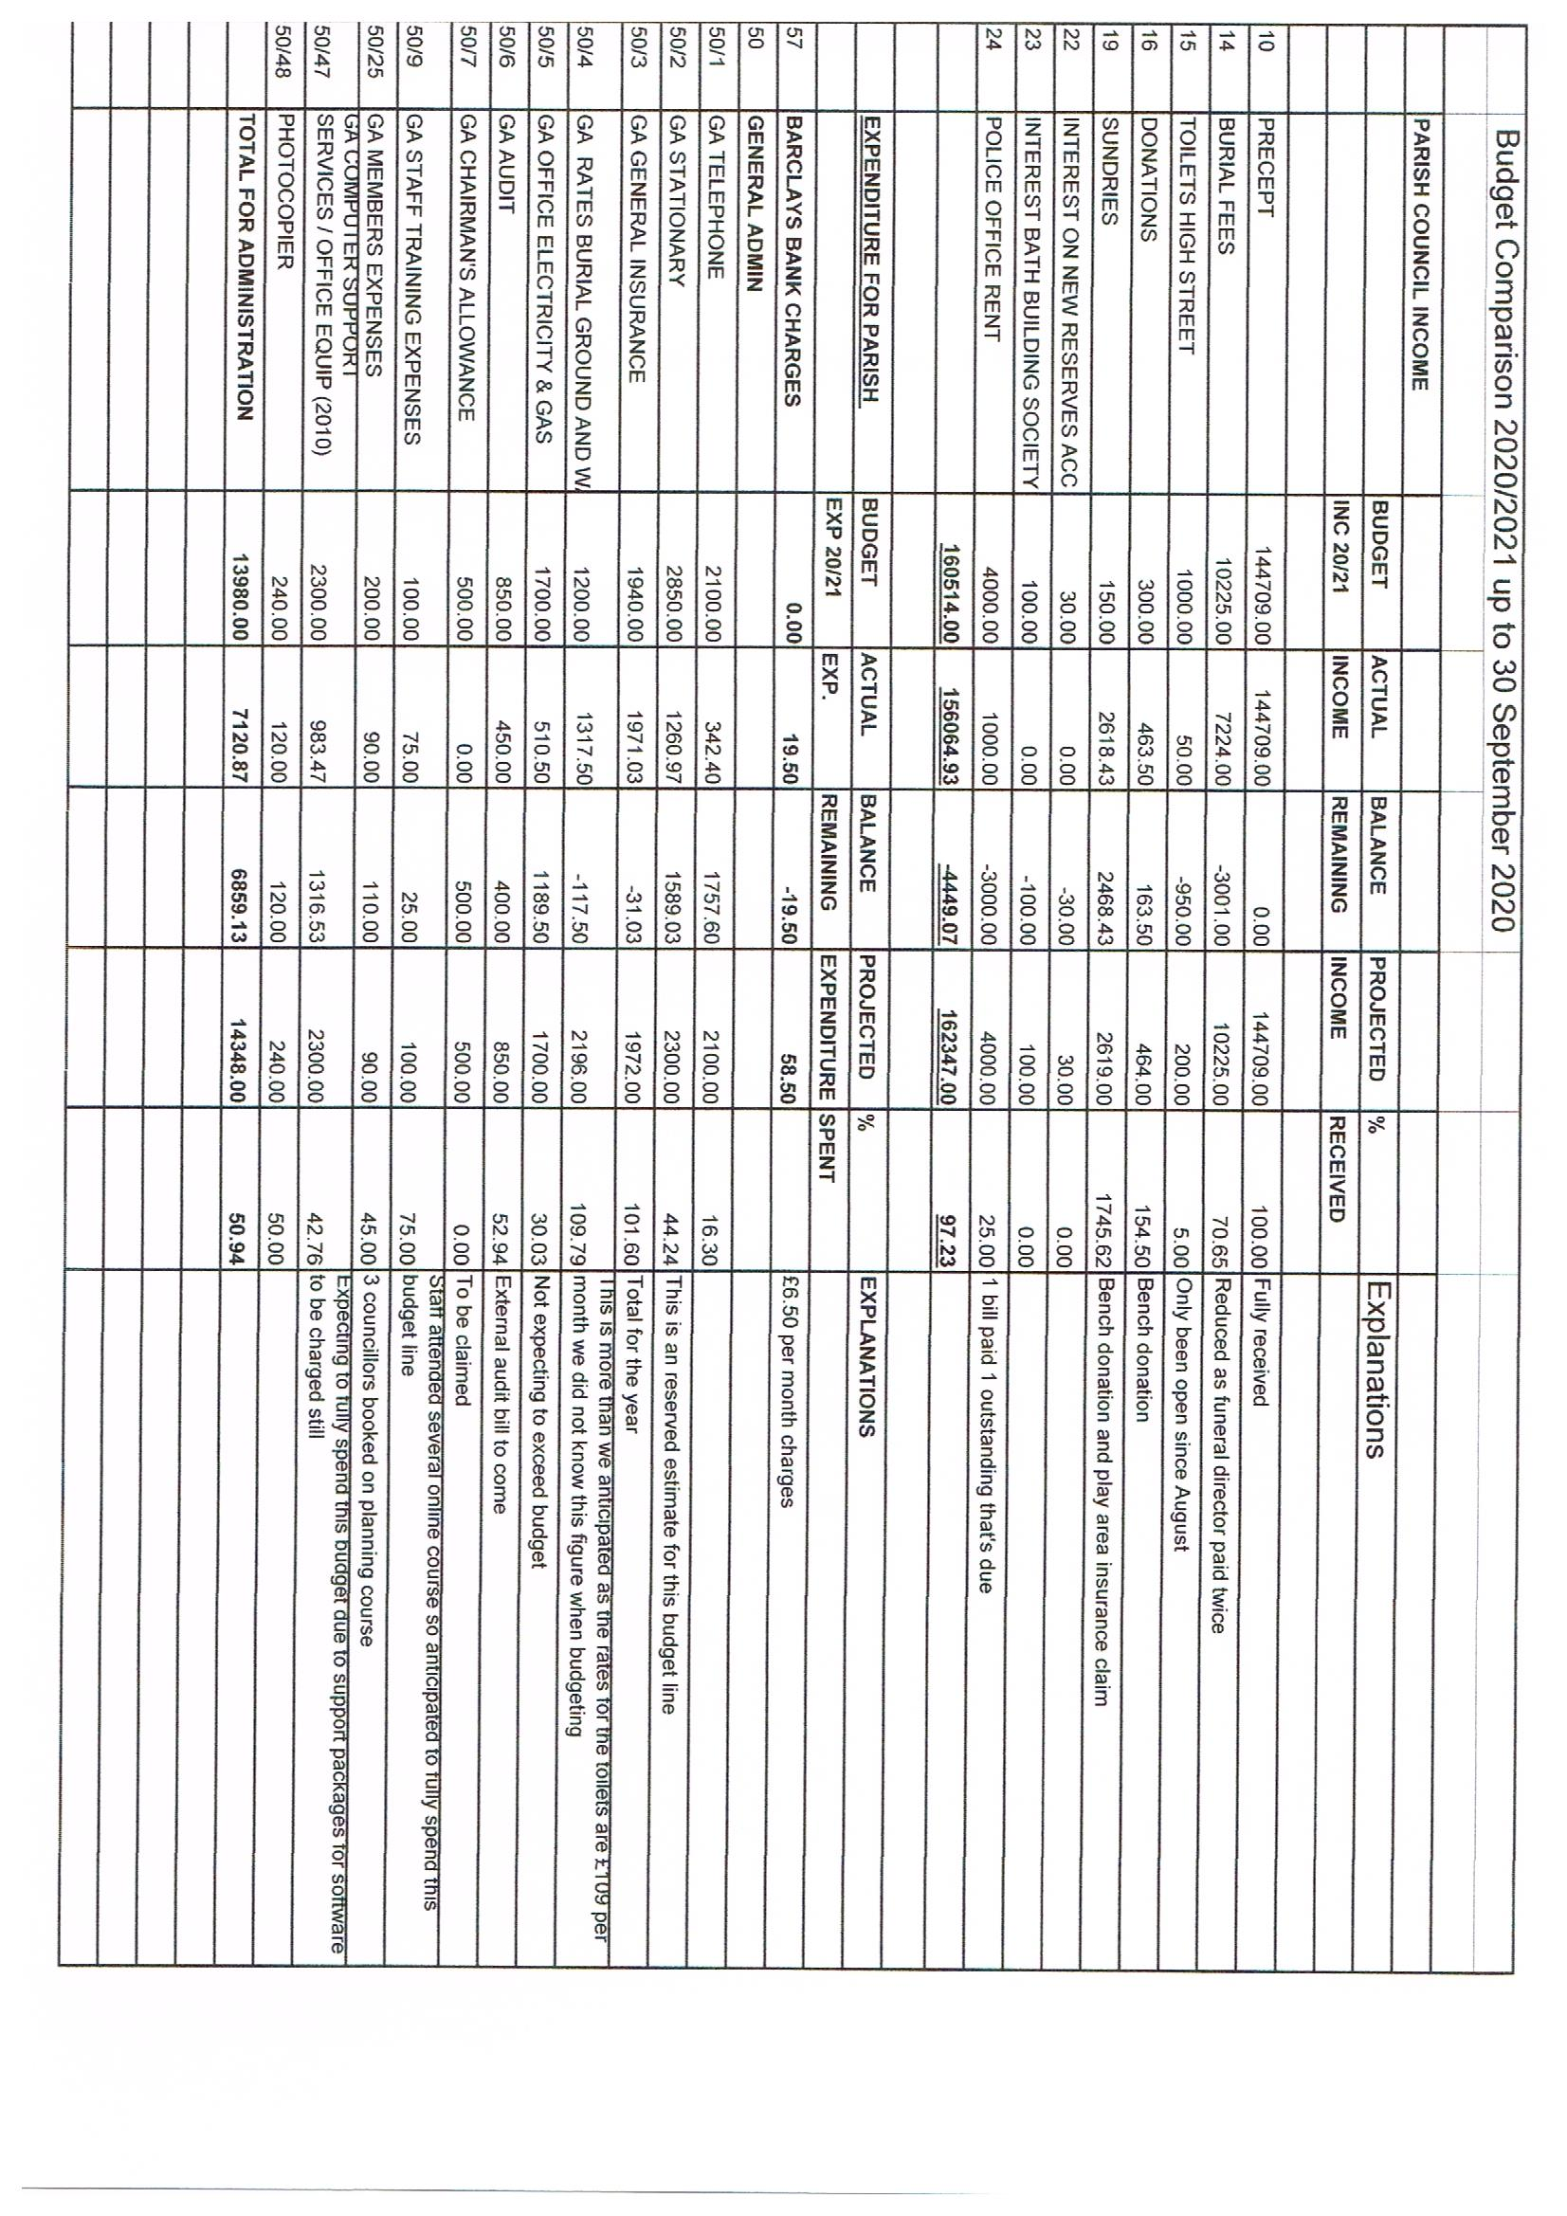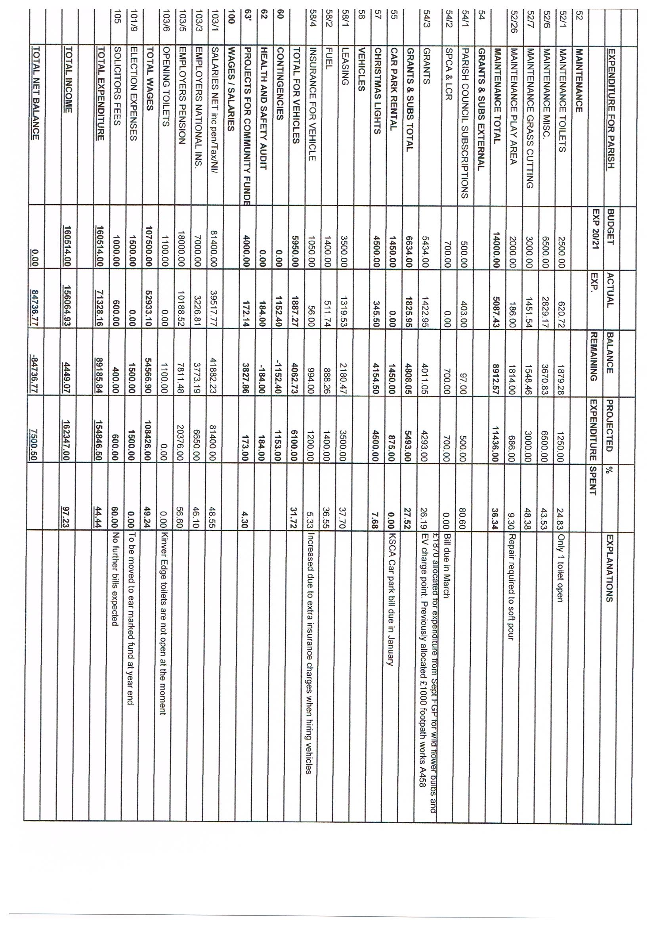

Appendix 2 to the minutes of the Finance and General Purposes Committee meeting held on the 18TH November 2020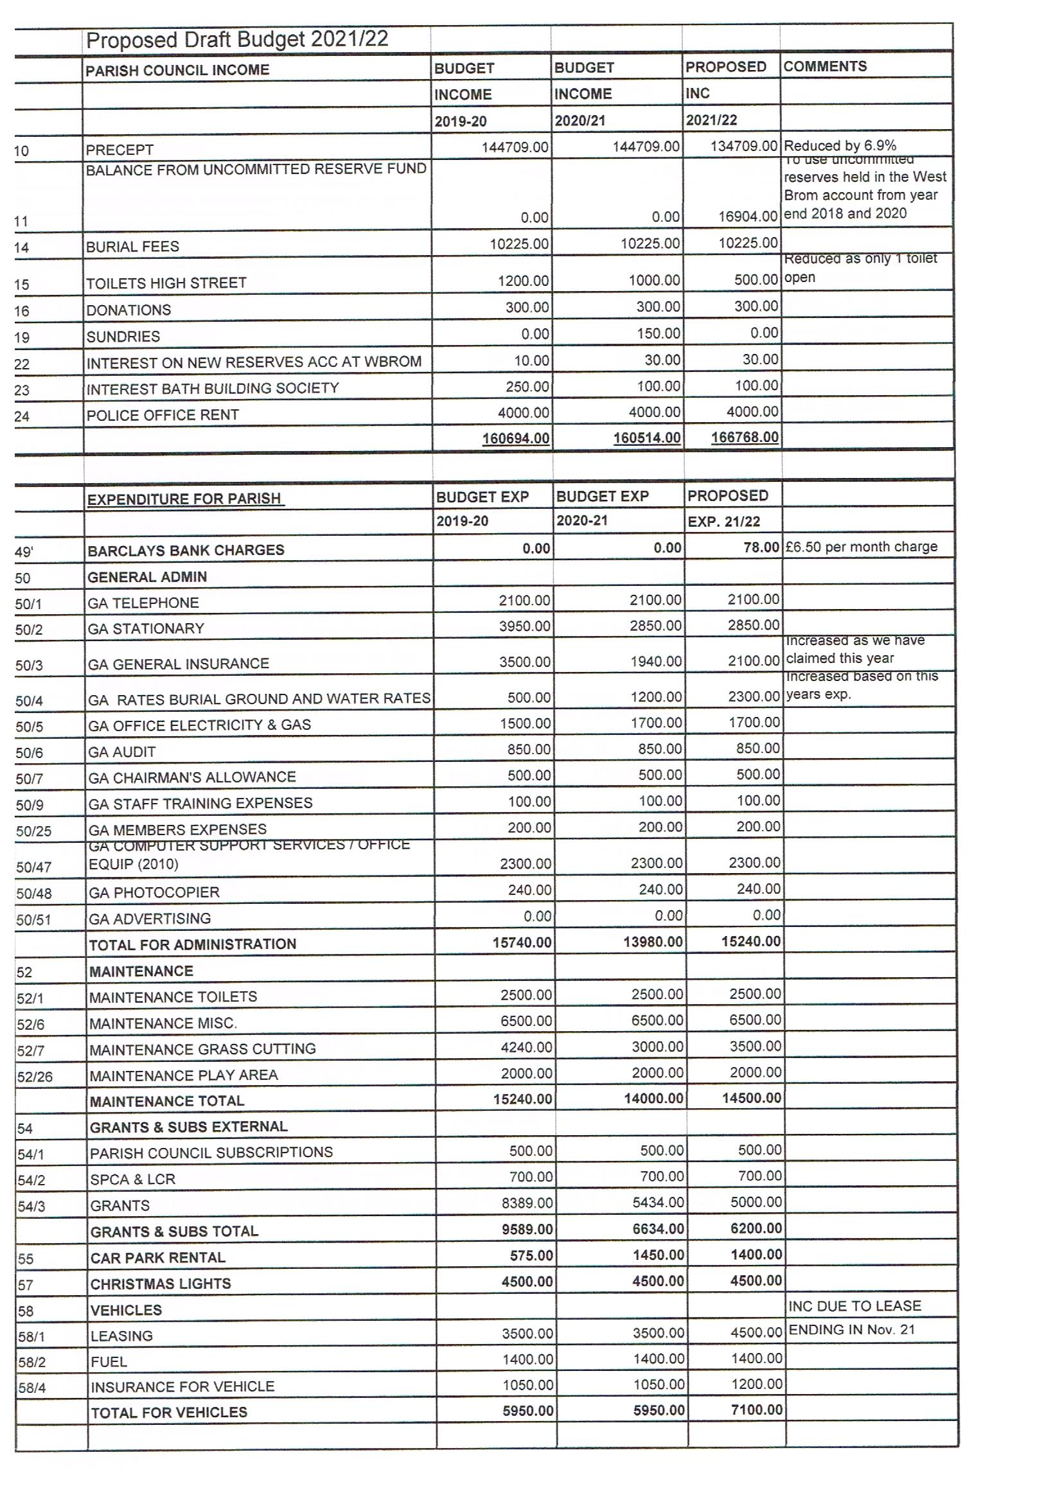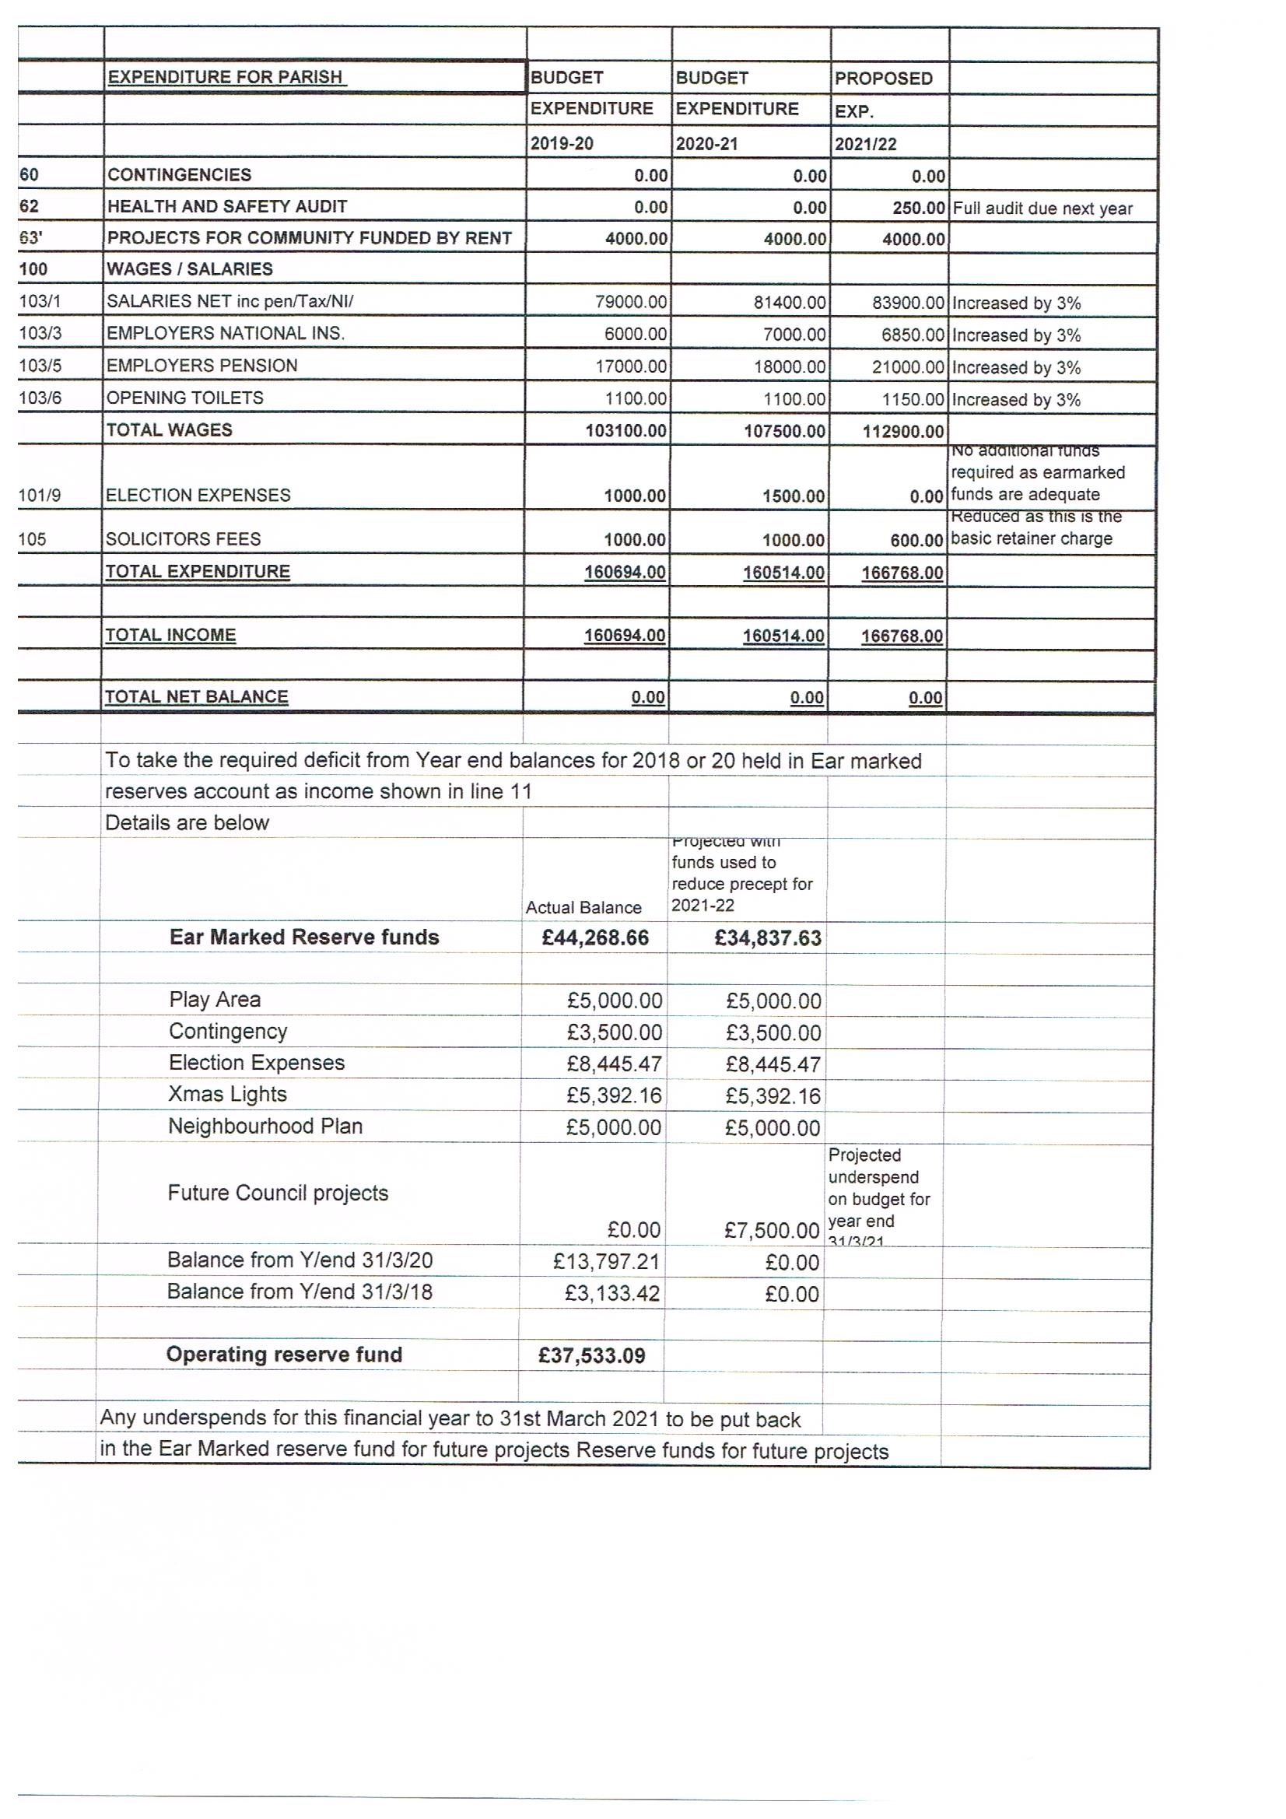

Appendix 3 to the minutes of the Finance and General Purposes Committee meeting held on the 18TH November 2020
Review dates:

KINVER PARISH COUNCIL RESERVES POLICY
Adopted at the full Council meeting on

INTRODUCTION
The Council is required, under statute, to maintain adequate financial reserves in order to meet the needs of the organisation. Section 50 of the Local Government
Finance Act 1992 requires that billing and precepting authorities in England and Wales have regard to the level of reserves needed to meet estimated future expenditure when calculating the budget requirement.
However, there is no specified minimum level of reserves that an authority should hold and it is the responsibility of the Responsible Financial Officer (RFO) to advise the Council about the level of reserves and to ensure that there are procedures for their establishment and use
The Council will hold reserves for the following main purposes:
- A working balance to help cushion the impact of uneven cash flows, provide contingency, and avoid unnecessary temporary borrowing; following guidance and recommended good practice (e.g. JPAG Practitioners Guide, NALC, SLCC)
- Earmarked funds to meet known or predicted specific requirements or improvement projects, and funds earmarked for statutory reasons. The setting aside of funds over a period of time to meet known future expenditure reduces the impact of meeting the full expenditure in one year.

This policy on the establishment, maintenance and adequacy of reserves and balances will be reviewed annually.

WORKING BALANCE / GENERAL FUND
The general fund, commonly termed the ‘working balance’, is a balance on the council’s revenue account which is not held for any specific purpose other than to cushion the council’s finances against any unexpected short-term problems in the council’s cash flow.
Sometimes mistakenly called a ‘general reserve’, the general fund (plus or minus any budget under/over spend) is only designated ‘General Reserve’ at year end for accounting purposes.
The level of general funds or working balances is a matter of judgement and this policy does not prescribe a specific level. However, Council must maintain sufficient working balances to cover the key risks it faces, as expressed in its financial risk assessment. The levels may change from year to year.
Guidance states that ‘a council should typically hold between 3 and 12 months expenditure as a general reserve’ (Good Councillors Guide on Finance & Transparency 2017). For a council of this size, expenditure, and risk, this could be narrowed down to between 6 – 9 months (50 – 75%) expenditure as a general fund, 50% being the absolute minimum acceptable level, with a preferred target of 55% - 70%.
1

Review dates:
Financial Risk Management: The general fund balance is to be maintained at a level based upon a financial risk assessment carried out by the Responsible Finance Officer (RFO) when setting the budget for the forthcoming year. The RFO will take account of the strategic, operational, and financial risks facing council and base the assessment on Council’s areas of income and expenditure and take into account any provisions and contingencies that may be required.
A surplus on the general fund above the agreed required balance may be used to fund capital expenditure, be appropriated to earmarked reserves, or used to limit any increase in the precept for the subsequent year. If the general fund becomes depleted below the minimum recommended by the RFO and accepted by Council, the fund will be built up in subsequent years (primarily through an allocation from the annual budget) to the agreed minimum balance.

EARMARKED RESERVES
Earmarked Reserves represents amounts that are generally built up over a period of time which are earmarked for specific items of expenditure to meet known or anticipated liabilities or projects. There will generally be a specific reason & purpose, limitations on how & when the reserve can be used, and management & control through annual review.
The level of earmarked reserves should be reviewed by Council as part of the annual budget setting process in November, to ensure continuing relevance and adequacy.

STATUTORY EARMARKED RESERVES
Local Authorities also hold reserves that arise out of the interaction of legislation and proper accounting practices. At Kinver Parish Council this is:
Play Area, Contingency, Election Expenses, Xmas Lights, Neighbourhood Plan, General Reserve fund.

Appendix 4 to the minutes of the Finance and General Purposes Committee meeting held on the 18TH November 2020
KINVER PARISH COUNCIL
Notice of conclusion of the audit
Annual Return for the year ended 31st March 2020

Section 25 of the Local Audit and Accountability Act 2014
Accounts and Audit (England) Regulations 2015

 | Notes
1. The audit of accounts for the Council/Meeting (a) for the year ended 31 March 2020 has been concluded.  2. The Annual Governance and Accountability Return is available for inspection by any local government elector of the area of the Council /Meeting (a) on application to: | (a) Delete as appropriate
(b) JENNIFER NEAL – PARISH CLERK  95 HIGH STREET  KINVER _____________________________________________________ | (b) Insert name, position and address of the person to whom local government electors should apply to inspect the Annual Return
2. Copies will be provided to any local government elector on payment of £1.00 (c) for each copy of the Annual Return. | (c) Insert a reasonable sum for copying costs
Announcement made by: (d) JENNIFER NEAL | (d) Insert name and position of person placing the notice
Date of announcement: (e) 20TH OCTOBER 2020 | (e) Insert date of placing of the notice

