MINUTES OF THE PLANNING AND DEVELOPMENT COMMITTEE MEETING HELD ON THE 28TH OCTOBER 2020 AT 7.00PM VIA ZOOM SOFTWARE
______________________________________________________________________________

Present: Councillors: Mrs C Allen (Chairman), JK Hall (Vice Chairman), G Sisley, S Anderson, Mrs E Lord and Miss V Webb.

Member of the Public present Gaynor Best

1. APOLOGIES FOR ABSENCE

Councillors E Simons, M Smith, P Wooddisse sent their apologies for the meeting.

2. TO RECORD MEMBERS DECLARATIONS OF PECUNIARY INTEREST

There were no declarations of Councillors interest declared.

3. TO APPROVE THE MINUTES OF THE PREVIOUS MEETING HELD ON THE 30TH SEPTEMBER 2020

The minutes of the meeting held on 30th September 2020 were approved and signed as a true record of the proceedings of that meeting.

- TO NOTE ANY ENFORCEMENT MATTERS RECEIVED

None were received.

5. PLANNING APPLICATIONS

20/00759/FUL Whittington Hall Lodge, Whittington Hall Lane
Alterations and extensions

The proposed alterations to this building would be detrimental to the area, they would be intrusive on the rural landscape and the Greenbelt, in addition near this property is a listed building with a medieval dovecote which would be impacted by these proposed alterations. The Conservation Officer should be asked to look at this application in detail.

20/00724/LUE 6 Round Hill Farm Cottages, Whittington Hall Lane
Use of land as garden lane

This application has ben approved already

20/00818/VAR Edgewood House, Greensforge Lane
20/00811/S106 Remove condition 2 of approval (05/00325/FUL)

We have no objection to condition 2 being removed to allow the building to be leased or sublet, however we would expect that the building remains as one site and so an additional S106 should be placed on the building so the site remains as one curtilage.

20/00783/FUL 3 Dunsley Road, Kinver
Single storey kitchen extension to the rear of property

Recommend approval subject to complying with Greenbelt and Conservation regulations, all building materials should be of a sympathetic type for the area.

20/00788/FUL 18 Hillboro Rise, Kinver
Construction of a detached bungalow

Recommend Refusal on the grounds that:-

- The area was originally designed with limited parking in front of properties and the garages were provided for this reason, in allowing the removal of the garages this has a major impact on the original ethos of the area.
- It will totally change the street scene.
- The loss of parking is unacceptable, as the car park / garage area is used to get cars safely parked away from being parked on the pavement. Although the other garage area is to remain, for those living at the top of the road, this will not be helpful. It was noted that residents from Enville Road also park in this street as they have no off-street parking.
- Highways need to visit the site (at an appropriate time) to look at the impact that this development would have to the existing residents.
- A plan is attached showing the residents that have parking (as appendix 4 to these minutes).

The Clerk to contact the Housing Association to discuss the concerns of the Council and local residents over the loss of parking in this area.

20/00888/TREE Ridgehill, Kingswinford
TPO 24/1966 W1 reduce and prune trees adjacent to property

Refer to Steve Dores

20/00847/VAR Kinver High School, Enville Road, Kinver
Variation of condition 10

Recommend Approval

20/00877/FUL Cedar Cottage Little Oaks Drive Lawnswood
Proposed extensions, alterations and changes to fenestration

Recommend Approval subject to complying with Greenbelt regulations

20/00881/TREE Ridge Hill Woods, Lodge Lane
TPO 24/1966W1. Sycamore - Remove 2 branches and other squirrel damaged limbs throughout the crown
TPO 24/1966, W1. Sweet Chestnuts (1-5 on plan) - Crown reduction, lifting and thinning. Pine(s) 6 on plan - Remove
Refer to Steve Dores

6. PLANNING DECISIONS REACHED BY SOUTH STAFFORDSHIRE DISTRICT COUNCIL

The Planning decisions are set out as appendix 1 to these minutes were noted.

- TO DISCUSS ANY FURTHER ACTION REQUIRED FOR THE NEIGHBOURHOOD PLAN

The notes from the working party meetings so far to date, are attached as appendix 2 to these minutes.

The chairman updated members as follows:-

- The questionnaire is being worked and is being progressed in the initial stages by Councillors Mrs E Lord, G Sisley, S Anderson.
- The first phase of the grant has been approved.
- The website should be live in a week or so.
- The terms of reference as attached to these minutes were agreed and put forward to the Parish Council for formal agreement.

- TO NOTE OR COMMENT ON ANY APPEAL NOTIFICATIONS

Planning appeal for the following application:-

19/00973/FUL Land adjacent to 26 Dark Lane, Kinver Ref. Rec Ref.
New dwelling
This was noted.

- TO DISCUSS / COMMENT ON THE GOVERNMENT CONSULTATIONS RELATING TO PLANNING

It was agreed to send out the comments as attached as appendix 3 to these minutes.

- ITEMS FOR FUTURE AGENDA

To be with Clerk by the 16th November 2020.

- DATE OF NEXT MEETING

The date of the next meetings:-

Neighbourhood Plan meeting 11th November at 6.00pm
Planning Committee 25th November 2020 at 7.00pm.

- RECOMMENDATIONS TO THE PARISH COUNCIL

The following recommendations were put to the Parish Council next meeting that:-

- the planning recommendations as set out in agenda item 5.
- the terms of reference for the Neighbourhood Plan working party are accepted as per appendix 2

Appendix 1 to the minutes of the Planning and Development Committee held on the 28th October 2020

19/00825/COU The Fox Inn, Bridgnorth Road, Stourton Ref. Rec App.
Change of woodland to car park

20/00683/LUP 2 Heathermount Grange, Kinver App.
Proposed demolition of conservatory and
construction of new permanent extension max 4m
deep and max 4m high

20/00597/FUL Stourbridge Rugby Club, Stourton App. Rec App.
Equipment store

20/00559/FUL 50 Sugarloaf Lane, Iverley App. Rec App.
Single front storey extension

20/00751/AGR Hillfields House, Prestwood Drive permission Not required
Proposed agricultural storage building

20/00693/LUP 7 County Lane, Iverley App.
Detached double garage

20/00431/FUL 26 Dark Lane, Kinver Ref. Rec Ref.
Revised design for previously approved
replacement dwelling (ref 0291/97)

20/00412/FUL Mile Flat House, Mile Flat App. Rec App.
New gates, walls, piers and ceilings

20/00724/LUE 6 Roundhill Farm Cottages, Whittington Hall Lane App. No comment
19/10

Appendix 2 to the minutes of the Planning and Development Committee held on the 28th October 2020

Kinver Parish Council Neighbourhood Development Plan

Terms of Reference of the Steering Group

Objectives of the Steering Group
To facilitate the process of achieving an adopted Neighbourhood Development Plan for the future development and sustainability of the Parish of Kinver.
To develop the Neighbourhood Plan through consultation with the local community and with due consideration for the needs of all residents and businesses in the area, now and in the future.
To ensure that the Neighbourhood Plan Is supported by evidence and complies with relevant existing plans.

Roles and Responsibilities
Kinver Parish Council is the qualifying body for the preparation of a Neighbourhood Development Plan for Kinver parish. The Parish Council has granted delegated authority in exercise of all relevant plan-making functions to the Kinver Neighbourhood Planning Steering Group.
The Steering Group will aim to achieve the following goals :
    - Manage and co-ordinate the production of a draft Neighbourhood Plan through to submission for Examination.
    - Manage the decision making process in an open, transparent and accessible way, and in consultation with the local community.
    - Manage the gathering of evidence to support development of Plan policies.
    - Ensure the Plan and the development process comply with legislative requirements and the Local Plan.

Membership & Governance
Membership of the Steering Group will comprise of Parish Councillors and volunteers drawn from the local community. Decisions made by the Steering Group should normally be by consensus at Steering Group meetings. Where a vote is required each member shall have one vote. A minimum of four members shall be present where matters are presented for decisions to be taken. A simple majority will be required to support any motion. The Chair, or in their absence the Vice-Chair shall have one casting vote
The Steering Group shall aim to meet once per calendar month, or as may be required, with notice being given prior to a meeting taking place.
Members of the Steering Group will debate the issues and policies inherent in the production of the Plan in consultation with the community.
The Steering Group shall appoint Sub Groups to operate on its behalf. Members with particular expertise in certain areas will head up specific projects / policies. Involvement in the Sub Groups shall include at least one member of the Steering Group, and shall be drawn from Parish Councillors and volunteers in the community that live, operate a business, or hold a specific interest in the Parish of Kinver and have expressed an interest in taking part.
Members of the Steering Group or sub groups will be expected to exercise balanced consideration for the needs of all aspects of the local community. The Steering Group and sub groups shall not be affiliated to any political party.
Declarations of Interest will be dealt with as per the Parish Council’s Standing Orders, in that anyone who has a pecuniary interest in the policy/project under discussion will be asked to declare it, and if deemed necessary will not take part in that discussion. This may include membership of an organisation, ownership of land or a business, or any other matter that may be considered to be relevant. Such declarations shall be recorded and be publicly available
When required, or if a member is not willing or able to continue as a member of the Steering Group, members can be replaced; and additional members may be invited to attend to further a project or policy.
Members may be excluded from the Steering Group or Sub Group for conduct and behaviour that is disruptive and does not promote the aims and objectives of the Steering Group or Sub Group. Exclusion of members will by a majority vote of the Steering Group.

Reporting and Feedback
The community will be encouraged to share knowledge and views, and contribute to development of the Neighbourhood Plan, by a managed process of public consultation and involvement.
All meetings, minutes and notices will be in the public domain and will be posted on the Neighbourhood Planning website and Public Notice Boards, copies will be kept by the Parish Clerk for public inspection. Minutes of Steering Group Meetings will be made publicly available within fourteen days of the meeting.
The Steering Group will report monthly to the Parish Council . The Parish Council will approve the Submission Draft Neighbourhood Development Plan prior to publication for consultation and independent examination.

Resources and Finance
Grant funding and technical support from MHCLG for development of the Neighbourhood Plan will be applied for. Other funding streams will be investigated.
Mentoring and guidance will be sought from Officers at South Staffordshire District Council to ensure that we achieve the best possible outcome for the Parish will also be sought.
Subsequent resources required will be determined by the Steering Group.
The Parish Council will oversee the expenditure and programme of work as advised by the Steering Group.
Organisations and businesses may assist in the production of the Neighbourhood Plan and may contribute to the cost of producing it. Details of any donations or assistance must be made publicly available and must not influence the recommendations of the plan.

Monitoring & Review
Monitoring of the plan will be ongoing, with regular reports from the Steering Group, and progress will be monitored by the Parish Council.

Kinver Neighbourhood plan
15th September 2020 at 2.30pm via zoom
1st meeting of the steering committee
In attendance: Eunice Lord, Virginia Webb, Steve Anderson, Geoff Sisley, Christine Allen
Apologies: Jenny Neal, Ed Simons, Paul Wooddisse

Topic - What next, how do we get started.

1. About a month ago Jenny submitted to district a letter of intent and map showing the area that will be covered in our neighbourhood plan. We are still waiting for a response and acceptance. This should be a quick process. Jenny sent a letter chasing this approx. 14th Sept.
2. When this has been accepted by district, we can then send the online Expression of Interest form which is the pre-Grant application form. This predetermines which pages of the grant we need to complete.
3. We shall apply for the standard grant and technical support at this stage. Add ons ie. Design Code and allocating sites for housing can trigger a further grant of up to £8000. We shall discuss this later.
4. It was unanimously agreed our consultants will be Kirkwells and our personal consultant - Louise Kirkup
5. Eunice to inform her. - Done 16.09.20
6. Terms of reference to be written - Jenny will do
7. Steering group. It was decided we don’t want too many on the group. Until the grant is accepted, we won’t involve outsiders, but must stay open at all times. We can always add extra people from the council or non-councillors as and when we need them.
8. Eunice has made a Google sheet with ideas of what we want in the neighbourhood plan. When we can all get access to it and write our suggestions and comments on it, she will circulate this. At the moment it is view only.
9. When the grant has been approved, we will make a Facebook page for the neighbourhood plan and create a website. This to be discussed at a later stage. - Action possible Jenny or Andy Callaway
10. Thoughts of who might be useful for historical information: Historical society, Civic society, Ed Simons, Virginia Webb
11. We must engage openly with the public on the Neighbourhood plan once the grant has been accepted. A Questionnaire for the public to complete will be submitted. - Christine to do.

Next meeting 29th September 2020 at 5.30pm via Zoom - Jenny to send invites

Brief notes from Neighbourhood Plan Steering Group meeting held on the 29th September

Present: Christine Allen, Eunice Lord, Mark Smith, Steve Anderson, Mark Smith, Virginia Webb and Louise Kirkup.

Suggested steering group is a core of 5 Councillors with 2-3 other members of the Community that drop in and out of the process as required. Maximum of 8

Other members would be business owners, groups such as Civic and Historical societies.

Suggested to involve people at an early stage of the process rather than it being after major discussions have taken place.

Key Themes

Housing
Required an affordable housing survey – possibly get the Housing Association to work with the Council on this
Affordable housing can mean – buy, rent, shared ownership, shared equity…
Greenbelt exception sites for affordable housing may be included (such as the Swindon site).

Conservation and design
SSDC should have a village design guide that they work too, but members felt this was an important part of our plan for us to include.

Members are sceptical that house builders are only giving lip service to eco friendlier designs of houses and doing the basics o their designs.

A list of all Heritage assets such as sand stone car garages etc needs to be prepared, Christine Allen will speak to Ed Simons on this matter.
The SAD process that has already approved sites will not be able to be tackled by using our Neighbourhood Plan as those sites have been chosen.. However, the plan could be used to help with the design of properties etc.
The plan can only be referred to when it has been completed and published. However due to the Corona Virus, referendums cant take place until next year, so any plans that have been prepared to that stage can be referred to.

Economy facilities
The Plan can include uniform or specific style type for shop fronts, this would be with consultation with local businesses.
Look at having a general space for meetings or hiring for local people, especially in light of people working from home. I.e. Spar perfect space.
Tourist area – promotion

Speak to local sports clubs and societies to ask what their plans are for the future what growth they would like to achieve. This information is then helpful for if developments happen for the developer to contribute
To these projects.

Natural Environment
Look at Green spaces to make special areas of interest, Wildlife Trusts may be able to help with surveys they have undertaken.

SSDC should prepare a screening opinion on the Strategic Environmental Assessment, they should be contacted now to get agreement and then this is prepared after the draft plan is in place.
We need to contact National Trust, Canals and Rivers Trust, Worcestershire and Staffordshire Wildlife trust to help with the environmental assessment data.

If it is required ACOM can produce a detailed report.
Contacting Local history groups to also increase knowledge base.

Accessibility
Plan cant look at reducing speed limits within the Parish.
Can look at Public transport requirements, issues and options on parking, schemes such as park and stride

Anything else
Climate emergency – zero carbon agenda
Environment design and sustainability
Flooding – may be better addressed through SSDC – but extreme weather will have an impact.

For Louise only have 1 point of contact which will be Eunice, if she is not available then Christin will contact.
Meetings scheduled for Friday 2nd October at 9.30 to run through application form with Eunice, Jenny and Christine.
Agreed to have a main topic per meeting to discuss in detail.

Next meeting 14th October at 7.00pm.

Meeting held on the 7/10/20
Present: Councillors Mrs C Allen, Mrs E Lord, G Sisley, S Anderson, P Wooddisse, H Williams
J S Neal and M Fullwood
Progress to date
Area designated by SSDC
Grant Application submitted
To Do
Web site –
Andy Calloway to prepare website
Domain names purchased as many variants as possible.
Layout needs to be agreed 3-4 to look at and give Andy a format to prepare. (EU, GS, SA, CA)
Look at other sites and pick and choose what we want.
Monday 12th October at 10am in Kinver Parish Office.
Terms of Reference
Agreed the final draft
Not set limits on group as people will come in and out of the group as required.
SA has spoken to Historical Society contacted
FoKos – spoken too
Civic Society not contacted yet.
Keith Jones – to be contacted re cycling
Joshua Worcestershire Wild Life Trust consultant – re White Hill contacted but not spoken in detail
Prepare questionnaire to be drafted
Members to look at questions to apply to all – members to forward questions to start the list
4 areas of topics as prepared by Louise, then have questions within those headings, and then have sub groups for those 4 areas.
Design Code is a separate area – and we can get official technical help for that.
Ed Fox at SSDC – Discussion with what help they can give us. To be invited to a meeting.
Next meetings
14th October @ 7.00pm via zoom. 21st October @ 7.00pm via zoom.

Working Party 14th October 2020 at 7.00pm via zoom.
Present: Councillors Mrs C Allen, Mrs E Lord, M Smith, S Anderson, E Simons, Mrs J S Neal and Mrs M Fullwood
Apologies for absence Miss V Webb, G Sisley and P Wooddisse
The following items were raised:-
- The grant application has been submitted and they have contacted the Clerk for clarification on a couple of points.
- On Monday a small group met to discuss the website design, Councillor Mrs E Lord has liaised with Andy Calloway on designing the website.
- For the website photographs are required Councillor Mrs C Allen will contact a local photographer. Also a logo needs to be designed for the group, Councillor Mrs E Lord to contact Andy Calloway to ask him to produce a logo for us that is meaningful for the whole parish.
- Councillor Mrs E Lord to discuss cloud storage with Andy also, to see what is the best option.
- The email address has been set up as kinvernplan@aol.com .
- Ed Fox at SSDC – Discussion with what help they can give us. He is to be invited to the next meeting. Clerk to circulate the previous information sent by him to all members.
- The next stage for the process is to prepare a questionnaire to go to each house. A link to the questionnaire can be put on a Facebook / webpage and in any publications that we may have access to such as CA Newssheet and other local magazines. It is easier to manage electronic responses, but we need to ensure all areas of the community get a say.

Councillor S Anderson to look at the cost for a freepost service for forms to be returned. We need to ensure people understand what a Neighbourhood Plan is and what limits it has to link to the questionnaire.

On the form the age range needs to be included and a postcode to help with analysis.

Clerk to look at other questionnaires and circulate to members and prepare a draft questionnaire to be discussed.

- Councillor E Simons to look into what buildings need to be protected by being listed and also looking at documents that may be useful to the plan.
- New members - we have been contacted by a Mr Conduit and also Emily Edwards who have offered their help to the process.
Next meeting
21st October @ 7.00pm via zoom.
Summary
Next steps
- Meeting Wednesday 21st October with Ed Fox
- Look at other leaflets for information on Neighbourhood plans to circulate
- Logo to be designed
- Questionnaire distribute other Parishes questionnaires and draft a basic document to work from.

Appendix 3 to the minutes of the Planning and Development Committee held on the 28th October 2020

White Paper Proposals - Consultation closing 28th October

Summary
We agree the planning system is over-complex, out of date and in need of reform, not providing many people with the homes they need and failing to value the climate, biodiversity or creating better communities.
However this white paper takes the wrong approach and indeed makes the wrong assumptions about what is actually wrong with the system, failing to look properly at the evidence and to understand the reasons for failed delivery of housing. It is a missed opportunity to address climate change, rebuild ecosystems and to bring forward proven solutions to the housing crisis including investment in local authority house building. It seeks simple answers without understanding the complexity of the problems. It is not based on the evidence available. It should not have been presented as a White Paper as it is nowhere near ready for legislation - it is entirely lacking in the detail in key areas.

We are opposed to this over-centralised approach which will damage local democracy and take away local control. This in turn can damage the reputation and confidence of the standing of property developers and the planning system in the local community. The failures including around infrastructure provision will have a detrimental effect on good neighbourhoods.

Climate change & Biodiversity:

There is a fundamental failure to place carbon reduction front and centre. Alongside the 10% net gain in biodiversity, there should be an equivalent commitment to carbon reduction. Every development should not only be carbon neutral but should be generating more power than it uses. The current proposal to be ‘carbon net zero-ready by 2050’ is simply not good enough.

The white paper is strangely silent on transport and the all-important need for the planning system to ensure that development takes place only in sustainable places with a commitment to a major shift from car journeys to sustainable modes of transport. Planning policy has a crucial impact on tackling climate change by building the right homes in the right place, with minimal use of resources for travelling between the concepts of home and work. All new homes should be designed suitably for working from home.

The replacement system of environmental assessments is deeply concerning, as there is no detail or even sense of importance about making these work better. A clear straightforward means of assessment that assesses carbon impact, constraints including flooding and air quality issues is needed.

Whilst the commitment to Biodiversity net gain is welcomed, we need to go much further, acknowledging the need for policy to address our biodiversity emergency, and catastrophic species loss in which land use - and loss - plays a crucial role. The metrics for Biodiversity net gain need to ensure we fully recognise the importance of no loss of a particular species loss or a long-established habitat such as ancient woodlands or wetlands in assessment of areas for development (not just assuming that for example an ancient woodland cannot simply be ‘replaced’ elsewhere).

The design codes proposed seem to be centred around beauty at the expense of sustainability and takes a gimmicky approach. Tree-lined streets are welcome but are not enough. In any case they must be the right species in the right place that will survive rising temperatures and not damage pavements.

Current local planning systems are one of the most effective ways for local authorities to tackle climate change. It is vital that the local design codes proposed are not restricted to dealing with appearance and ‘beauty’. Beauty is important but in any case hard to legislate for and can lead to pastiche. Lack of beauty is important - but not the biggest crisis facing us.

Design codes - both local and national - must allow for meaningful action on sustainability including local requirements for carbon neutrality in buildings, biodiversity, construction methods, and for infrastructure planning that puts requirements for walking, cycling and proximity to public transport at the heart to create liveable communities. They should be genuinely locally driven - this will not be achieved through a centralised system reliant on ‘machine reading’ instead of human planners.

Climate change will not be solved by using a more attractive cladding.

On Community Infrastructure Levy (CIL) reform, the new levy should not only be based on the type of housing but on the carbon and environmental credentials of a building and site, effectively offering a discount to those developers that build to the highest environmental standards and incentivising doing the right thing.

We are also concerned that the new infrastructure levy as proposed could be siphoned into non-infrastructure spending
- Bundling affordable housing in with infrastructure - when it isn’t - could reduce the amount of affordable housing provided (an impact compounded by the proposed changes to the current system - see our consultation response to changes to the current planning system)
- We are opposed to the suggestion that infrastructure levy could be used for other types of spend, unrelated to development and even ‘council tax reduction’ .

Affordable housing spend must be prioritised, and infrastructure spending must be ring fenced for the infrastructure needed to enable development and especially infrastructure for low carbon living and increased biodiversity e.g.
- Grid upgrades
- Provision of renewable energy including solar PV on all roofs as standard
- Rural and urban sustainable drainage
- Climate change adaptation
- Walking and cycle routes
- Public transport
- Schools, health & social care facilities
- Community & cultural space
- Local shops
- Parks and green spaces
- Allotments & other food growing space

If the new Infrastructure Levy is to be based on the value of the development, areas with low house values will lose out. This will work against ‘levelling up’. There is some justification for higher levies where there are high house values, as the high cost of land will also mean higher costs for providing infrastructure (and affordable housing) but this needs to be balanced. Any formula should take into account income and affordability, not just be set at a flat rate across the county.

If reform goes ahead we must see:

- Local design codes need to be able to incorporate areas which are currently set through local planning policy. They should not be purely about appearance and ‘beauty’ but allow rules addressing the climate emergency e.g. carbon zero building, transport design, building waste and packaging and materials minimisation.
- The energy efficiency standards required at national level are much greater than those proposed - requiring generation - or at the very least fully zero carbon.
- Rigorous environmental assessment.
- Meaningful biodiversity net gain which recognises species loss and the nature emergency
- Infrastructure contributions should incentivise high environmental standards.
- The infrastructure levy ring fenced for infrastructure especially low carbon infrastructure and balanced to ensure levelling up not levelling down.
- There needs to be the option to include conditions around the process of construction e.g. traffic and site management.

Use of land and meeting everyone’s housing needs

Failure to address the real barriers to house building - the need for land value tax, penalties for land-banking, resourcing of planning authorities and to invest in good quality council housing.

These proposals could lead to a proliferation of greenfield, out of town, car-driven developments which are loved by both the development industry and the land-selling industry because they maximise profits for both these industries. These dormitory housing estates are far less sustainable than brownfield development near existing transport and services and are often unpopular with communities as they take away precious open farmland and green space, as well as harbouring the potential for social isolation problems.

There is also clear evidence that the best way to bring about more and better housing of the kind needed by our communities, whilst at the same time stimulating our economy post Covid, is to make finance available to local authorities to build council housing and this white paper is a wasted opportunity to bring this about. We need to see a serious approach to affordable housing which also encompasses withdrawing the right to buy legislation. A proper definition of affordable housing is also required. The paper aims to provide at least as much affordable housing as under the current system but should be much more ambitious than that - particularly as regards affordable rented housing.

The white paper fails to address the failure of the house building industry to bring forward developments which have been given permission but which developers are failing to build out, instead ‘land banking’.

There is a gap around ensuring continued investment in affordable homes provided by community land trusts.

Additionally, we are concerned that the problem of systematic cuts from government leading to under-resourcing of local authority planning departments is not acknowledged or addressed. On top of the existing deficit, undertaking wholesale planning reform will require additional resources. There must be sufficient revenue to fund local authority planning departments to undertake the new requirements.

Additionally, to have any hope of success, substantial reform should not be taking place alongside a period of local government reorganisation (or ‘devolution’ as this is euphemistically being called) as the two things simply aren’t possible alongside each other.

We believe that reforming the planning system as suggested will not get more houses built because land prices and the profit to be gained from getting planning permissions on cheap agricultural land are not being addressed.

The White Paper instead should seek:
- to reform the Land Compensation Act 1961
- enhanced CPO and land assembly powers for local authorities
- Incentives for developers to go ahead with construction when planning permission granted, and penalties when they don’t (e.g. time limits, financial penalties)
- A carefully designed Land Value Tax
- Investment in council housing and stopping the Right to Buy policy - one counters the other
- Support for community land trusts
- Addressing the deficit in local authority planning services and additional resources to enable reform

Additionally, planning reform must not take place alongside local government reorganisation

Zoning

Concerns about ‘zoning’ / centralisation; democracy/accountability, and about deliverability in practice

In principle, there could be advantages to a more accessible and visual approach to local planning, if this genuinely allows communities to engage better at an earlier stage of the planning process. However, the proposals set out entirely lack detail about how this would be achieved and fail to address digital exclusion. Given the proposals were developed without reference to any expert in community involvement (or even a single local planning authority) it is not surprising that in practice the proposals are heavily skewed against a better deal for communities. The principles of localism appear to have been entirely abandoned. Localism needs to be embedded in the reforms, building on the work on Neighbourhood Planning that has been so successful in many parishes and towns around the country, an approach we strongly support.

We are hearing many concerns raised by both Councillors and residents in different areas of the country about the split into Growth/ Renewal/Protected zones and how this would work in practice. These are not sufficiently nuanced.

The proposals simply do not put our communities at the heart when it comes to decision making and they tilt the balance of the planning system further in favour of large scale development and land-buying industries. The zones are too broad and do not allow for local circumstances.

Growth zones must first pass environmental assessments / sustainability tests and the current proposals do not provide a practical way for this to take place - as there is no allowance in the process for resources needed for these assessments to take place prior to allocation.

The lack of clarity on the future role of local authority planning committees is a gaping hole in the current reforms. Whilst the idea of streamlining decision making to help bring forward more homes more quickly is welcomed, this must not be at the expense of the role of local councillors, who know their areas better, in scrutinising development proposals at all stages of the planning process. There needs to be the opportunity for communities’ specific comments on an actual project to be raised so they can be debated when deciding the outcome.

We are concerned that land seems to be viewed simply as a commodity, instead of a precious resource. Land - including open countryside which does not have an official designation such as an AONB - is fundamental to our lives. It is key to biodiversity, captures carbon, and is often hugely important to local residents. Additionally, smart land use for renewables, rewilding, food production etc. is key to a low-carbon future.

The importance of agricultural and food producing land must be remembered for food security.

Employment space is largely ignored which is a huge oversight. A joined up approach - that looks beyond an obsession with housing- also should consider the sustainability of future economies - with progressive design looking at ‘15 minute neighbourhoods’ or ‘1 job per household’ etc. Yet employment space barely features.

Waste and minerals planning should be reframed in a circular economy approach however seems to have also been forgotten in this White Paper so it is hard to comment.

Putting too much emphasis on a ‘fixed’ set of rules for development set at one particular moment in time means there is then no opportunity to respond through the planning system if local or national circumstances change - just as the pandemic should have taught us all about the need to retain the flexibility to adapt to changing times.

Conversely, if every single possible future scenario is planned for, design codes will become unworkably complex (as we see in other zoned areas e.g. the 1600 page New York design code) - entirely defeating the point of this reform.

This white paper is part of a centralising approach which reduces the power of local government, undermines democracy and which fails to recognise the importance of local communities and local areas who should be at the heart of effective placemaking.

We agree that the proposals would lead to greater complexity (despite the stated desire for simplifying the system) and especially the need for much greater clarity, made in the TCPA Initial Analysis. If reform goes ahead some of our key requirements are:

- The designation of Growth and Renewal areas MUST be co-designed with local residents;
- Growth zones must first past environmental assessments / sustainability tests.
- There needs to be additional categories in the zoning system e.g. protected to recognise the importance of open countryside and other undeveloped land separate to land which is designated as AONB, National Parks etc.
- There need to be additional categories of land use which will enable local areas to set local targets, for example
- Renewable energy generation
- Food production
- Rewilding and nature
- Carbon sequestration
- Involving people better earlier in the process must not exclude the involvement of communities later in the process as populations, and both local and national circumstances change.
- Digitally excluded people need to be included.
- Reducing the role of democratically elected councillors in the process would mean less accountability and this must not happen.
- There needs to be consideration given to the transition period - how do local authorities move from the current system to a future one without a policy void?
- Ensuring proper resources for local authorities to implement the new system
- Recognising and compensating for historic under-resourcing
- Ensuring local authorities have both the time and the money to provide the evidence base - and the community engagement needed for co-design that would allow them to allocate ‘growth’ zones,otherwise they are just fantasy

Re Neighbourhood Plans

A continuing commitment to Neighbourhood Planning is welcome however more investment is required to support communities to meet both the technical requirements and enable community participation. This should particularly focus on NPs in urban areas - as the vast proportion of NPs have been developed to date in parished rural areas.

Guidance on housing supply in NP areas should be provided, with a margin for flexibility over or under those numbers to allow especially small sites to be developed. The greater % of CIL to be allocated to an area with a NP should be maintained. The status and weighting of NP's and their policies in relation to the adopted plan should be clarified as part of any reform.

Public sector equality duty

It is disappointing that no equality impact assessment has been carried out. Despite the claim that the Government is “mindful of its responsibility” in relation to its legal duty under s.149 of the Equality Act 2010, and the fact this is described as a White Paper, there is no evidence that any steps have been taken to comply with this duty. The duty includes a “duty of inquiry” to find out the impact on groups with protected characteristics.
Disabled people face many more barriers than the general population, not just in terms of access to housing but also every aspect of their interface with the built environment. BAME populations may face additional barriers due to correlation with relative income profiles and to family size.
The PSED includes the particular duty to have due regard to the need to take steps to meet the needs of people with disabilities where they differ from the needs of those without disabilities. The White paper is silent on the integration of accessibility with development.
PSED also includes the duty to have due regard to the need to tackle prejudice and promote understanding. This may be particularly relevant, for instance, to the arrangements for affordable housing. Also with regard tof Gypsy and Traveller provision - which in the White Paper has apparently been forgotten. There should be provision in every area.
The proposal should therefore not be taken forward without a full equality impact assessment.

Appendix 4 to the minutes of the Planning Committtee meeting held on the 28th October 2020
Hillboro Rise, Kinver, planning application no. 20/00788/FUL
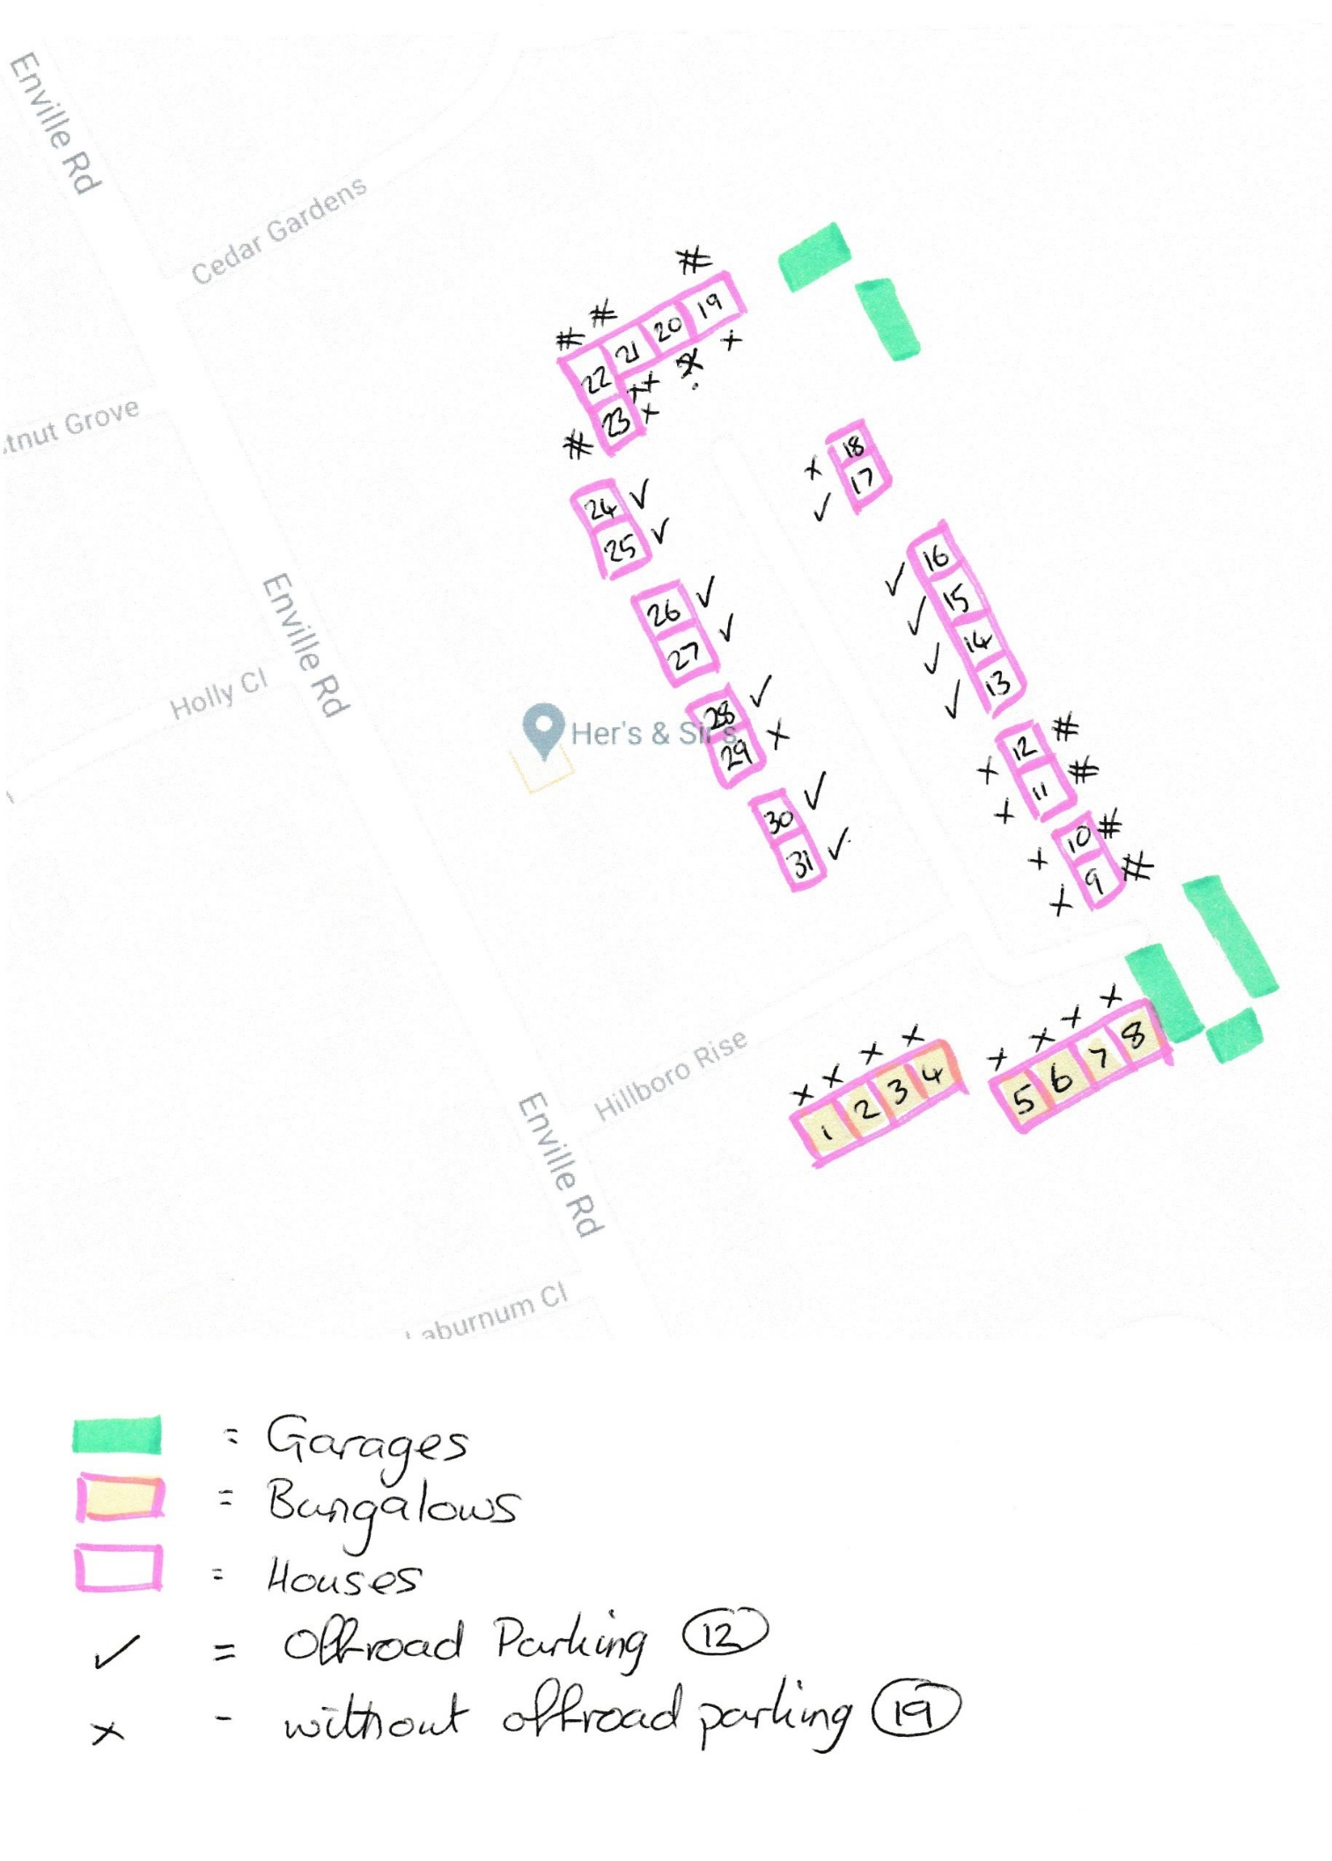
Bungalows no’s 1-4 on hill some with hand rails without off road parking
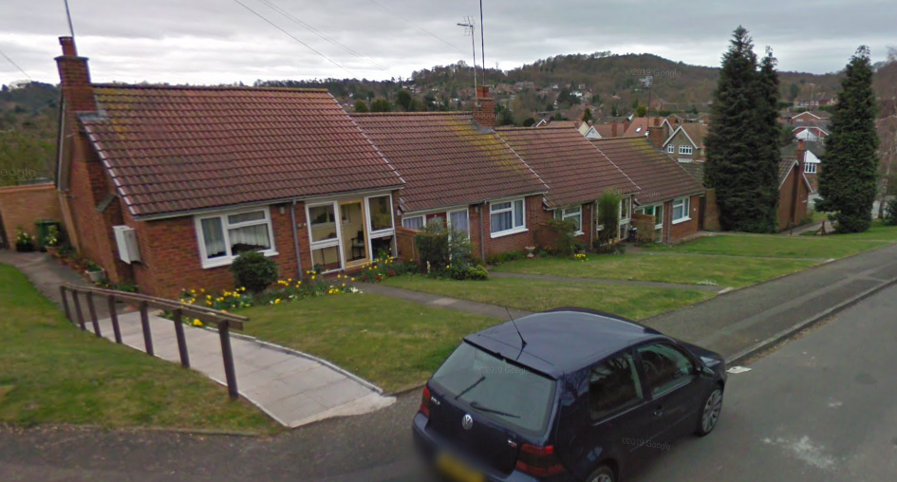

Bungalows No’s 5 to 8 hand rails without off road parking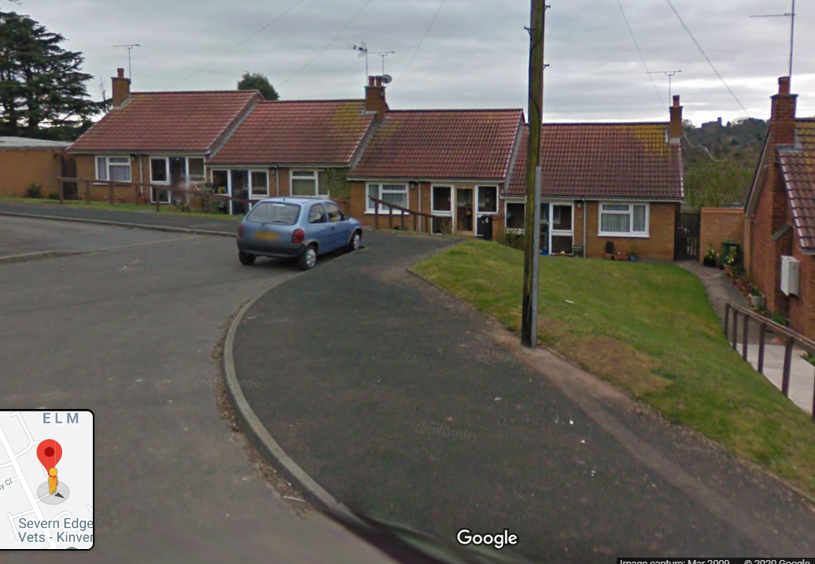
Houses No’s 9 to12 elevated from road and accessed via steps and pathway without off-road parking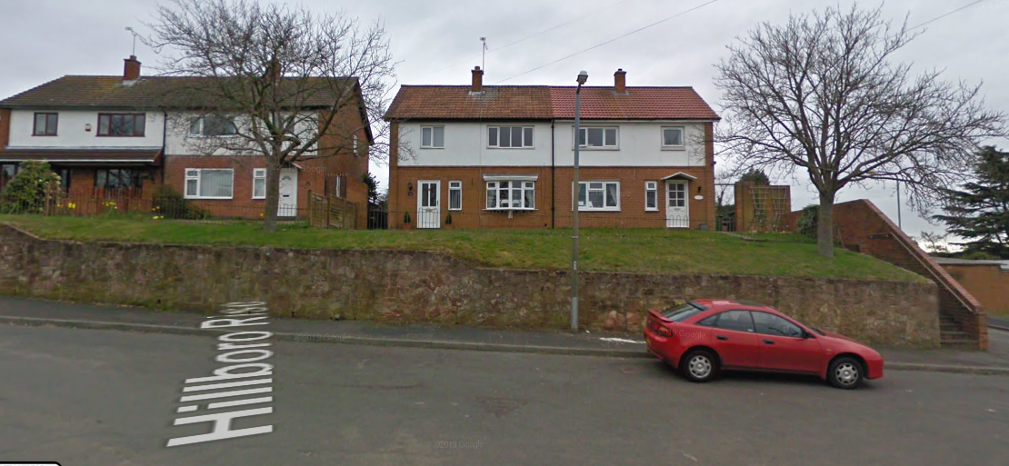

Cul-de-sac adjacent to proposed planning application No’s 19-23 – 5 properties without off-road parking 